DEVELOPMENT OF A WEB-BASED RECRUITMENT AND APPLICANT

MANAGEMENT SYSTEM (R-AMS)

A Thesis
Presented to the Faculty of the
College of Science
Technological University of the Philippines
Ayala Boulevard, Manila

By

Daryl T. Roallos

In Partial Fulfillment of the Requirements for the Degree
Bachelor of Science in Information Systems

March 2026

Approval Sheet

ABSTRACT

Technological adaptation is essential for human resource departments managing high applicant volumes, yet manual, spreadsheet-based methods still cause inconsistent data, duplicate records, and hiring delays. To address these inefficiencies within the BPO industry, the Web-Based Recruitment and Applicant Management System (R-AMS) was developed. This is a three-tier intranet web application that automates candidate pre-screening and centralizes the end-to-end hiring workflow. R-AMS combines PHP, JavaScript, and TailwindCSS for its dynamic front-end, utilizing a MySQL relational database on an Intel Xeon server for secure, localized data storage. It has the features of intelligent applicant web form with an automated scoring algorithm based on education and skills, a role-based HR administration dashboard equipped with smart filtering and interactive Chart.js analytics, and a dedicated interviewer portal. Furthermore, the system supports bulk CSV imports via PapaParse.js, customizable table columns, and dynamic data extraction for custom reporting. Validation through functional, compatibility, and usability testing with HR professionals and IT experts produced an overall ISO/IEC 25010 evaluation grand mean of 3.66 (Highly Acceptable). The project demonstrates a secure, centralized digital recruitment solution that reduces manual workload, eliminates data redundancy, and enables HR teams to execute faster, evidence-based hiring decisions

ACKNOWLEDGEMENT

My deepest gratitude goes to the Lord, whose presence, grace, and guidance have sustained me throughout my life, career, and academic pursuit. In my weakest moments, He gave me strength; in my confusion, He gave me wisdom. Every step of this journey has been possible only through Him.
To my family, my fiancée Kim, my co-workers, managers, AVP and Australian Clients who have supported me from day one and inspired me to pursue my dream of earning a bachelor’s degree I would like to express my sincere appreciation for your love, support, and encouragement. Your belief in me kept me moving forward, even during the most challenging times.
My heartfelt appreciation also goes to all my professors and panel members—Professor Dolores Montesines, Professor Peragrino Amador, Professor Fernando Renegado, Professor Edward Cruz, Professor Ariel Tomagan, and Professor Julius Sareno—for generously sharing their expertise, wisdom, and patience.
To my capstone adviser, Professor May Garcia, thank you for your invaluable guidance, dedication, and support. Your insightful feedback, patience, and words of encouragement play a crucial role in shaping this study and helping me overcome every challenge along the way.
I would also like to express my profound gratitude to Dr. Kevien Cabarrubias-Dela Cruz, Ph.D., Director of the Expanded Tertiary Education, Equivalency and Accreditation Program (ETEEAP) of the Technological University of the Philippines, for accommodating me and granting me the opportunity to pursue my studies, complete my academic journey, and fulfill my lifelong dream of graduating. It has been an honor to be part of this institution, and I am grateful for the program’s commitment to excellence that helped me reach this milestone.

Table of Contents
DEVELOPMENT OF A WEB-BASED RECRUITMENT AND APPLICANT MANAGEMENT SYSTEM 1
ACKNOWLEDGEMENT 1
CHAPTER 1 1
INTRODUCTION 1
Background of the Study 1
Objectives of the Study 3
Technologies Included: 4
Scope and Limitations of the Study 5
CHAPTER 2 7
CONCEPTUAL FRAMEWORK 7
Review of Related Literature 7
Digital Transformation in Human Resource Management 7
Pre-Screening Through Skills-Based Application Forms 9
HR Analytics and Data-Driven Recruitment 9
Challenges and Enablers of HR Digital Systems 11
Application Standard Requirements 12
Tools and Technologies for Developing the System 12
Software Testing Framework 15
ISO/IEC 25010 Software Quality Evaluation 16
Conceptual Model of the Study 17
Input 17
Process 18
Output 19
Operational Definition of Terms 20
CHAPTER 3 22
METHODOLOGY 22
Project Design 22
System Architecture Diagram 22
Software Design 24
Database Design 25
System architecture 27
Project Development 36
Evaluation Procedure 43

CHAPTER 1

THE PROBLEM AND ITS SETTINGS

Background of the Study
Technology changes every year, and we cannot control its pace. These changes, including AI, affect every industry differently, so adapting is necessary to keep up. In my experience working in the BPO industry for 15 years, I have seen our HR departments often use manual (Figure 1), spreadsheet-based methods to record, monitor, and evaluate applicants. Before the new system, recruitment relied on multiple Excel and Google Sheets files managed by different HR staff, which sometimes caused inconsistent data entry, duplicate records, and made it hard to combine information for reports and decisions. When applicants came on-site, they filled out paper forms, and HR staff re-encoded them. Applicants from online sources like Indeed or job ads were also processed through recruitment email inboxes, and HR staff had to manually enter their data into tracking files.
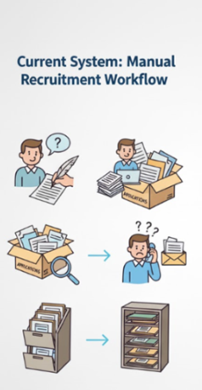
Figure 1. Current manual system on our HR dept

This manual and scattered process led to several problems. Without a central database, it was hard to keep applicant information accurate, consistent, and secure. The high number of applicants in the BPO industry also caused delays in screening and scheduling interviews. Because there was no single monitoring system, HR could have difficulty in tracking applicant status, interviews, deployment, recruiters' performance in real time. As a result, HR managers struggled to create reports and spot hiring trends needed to improve efficiency. Recent findings demonstrate that digital HRM systems significantly increase HR efficiency in organizations undergoing digital transformation (Mahmoud et al., 2025), which further supports the need to replace manual recruitment workflows with automated, data-driven systems.

There is now a greater need for a streamlined, data-driven HR recruitment process. Recent research also highlights that digital HR transformation goes beyond simple digitization of tasks—it requires structural changes, modernized workflows, and enhanced information systems to support more efficient decision-making (Bansal, 2023). These emerging trends show that many organizations are now adopting role-based access systems, interactive dashboards, and secure web applications to increase accountability, transparency, and efficiency in HR operations. (Figure 2)
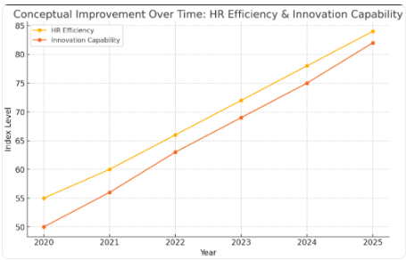
Figure 2. (Conceptual improvement over time using digital application)
To address these challenges, this research set out to design and build a Three-Tier Web-Based Recruitment, Interviewer dashboard and Applicant Management System (R-AMS) with an Applicant User Web Form and an HR Recruitment Management System, both connected to a centralized database. The intention of the project is to create an innovative, secure, and efficient recruitment tool that reduces manual work, keeps data accurate, and helps HR staff make timely, informed decisions. The study also sought to qualitatively understand user experience, workflow improvements, and system feasibility within an actual HR operational environment.

Objectives of the Study
The general objective of this study is to design and develop a secure, database-driven Web-based Recruitment System consisting of an Applicant Web form, HR Administration Dashboard for end-to-end applicant management and a dedicated Interviewer Dashboard for streamlined candidate evaluation. This will enables HR personnel to manage, update, extract, and visualize recruitment information within a role-based access environment using modern web technologies.
Specifically, this study aims to:
- Develop an Intelligent Applicant Web Form using HTML, CSS, and JavaScript that captures applicant data and implements an automated pre-screening algorithm to calculate initial qualification scores based on education, experience, and skills in real-time.
- Develop an HR Management System using JavaScript, PHP REST APIs, and MySQL with full CRUD functionalities for applicant records, interview schedules, and recruitment statuses to centralize data management.
- Implement a Role-Based Access Control (RBAC) System using PHP sessions to strictly separate the environments for HR Managers, HR Staff, and Interviewers, ensuring users are securely redirected to their specific dashboards upon login.
- A Dynamic HR Dashboard featuring an "Intelligent Smart Filter" mechanism that allows users to perform multi-criteria filtering and integrate a search mechanism for specific fields with bulk actions like "select all" for efficient record handling.
- A Customizable HR table interface per user, which allows the user to add or remove specific fields based on preference.
- Implement an Appointment Scheduling and Notification Module using PHP, JavaScript, and MySQL that prompts HR personnel for any upcoming or due interviews, ensuring timely candidate processing.
- Develop a Secure Interviewer Dashboard that provides assigned personnel with a restricted, real-time view of assigned interview schedules, secure access to candidate resumes, and a standardized interface for submitting ratings (1-5 stars) and feedback.
- Develop a Robust Bulk Import Module utilizing PapaParse.js that parses CSV files, validates data integrity, and automatically applies pre-screening scores to imported records to maintain consistency with individual/manual entries via recruitment form.
- Integrate Advanced Data Extraction Features that allow HR users to generate reports via Custom CSV Template Mapping, enabling the system to adapt to various reporting formats without code changes.
- Design a Custom Analytics Suite using Chart.js that visualizes key performance indicators (KPIs) such as Deployment Trends, Top Application Sources, and Recruiter Performance and etc., with interactive date-range filtering.
- Implement Strong Security Protocols, including SQL injection protection via prepared statements, encrypted password hashing (e.g., password_hash), secure session management, role-based access restrictions.
- Develop a Resume Management System that supports file uploads (PDF/Docs) to Google Drive, ensuring flexible document viewing for interviewers.
- Integrate a Comprehensive Audit Trail that logs all critical system actions (logins, updates, exports, and bulk uploads) to ensure accountability and data integrity.
- Evaluate the System based on ISO/IEC 25010 software quality standards, specifically focusing on functional suitability, performance efficiency, usability, and security, through user acceptance testing with HR personnel.

Technologies Included:

Category | Technologies / Tools
Frontend Frameworks & Design | • HTML
 | • TailwindCSS (Utility-first styling framework)
 | • Google Fonts ("Inter" typeface)
 | • FontAwesome (Iconography for buttons and dashboards)
Client-Side Scripting & Libraries | • JavaScript (Core logic)
 | • SweetAlert2 (Interactive modal alerts and confirmations)
 | • Chart.js (Data visualization)
 | • Chart.js Adapter Date-fns (Time-series support for charts)
 | • ChartDataLabels (Data labels inside charts)
 | • Litepicker (Date range selection)
 | • PapaParse.js (CSV parsing for bulk uploads)
 | • Choices.js (Enhanced dropdown menus)
Backend Development | • PHP (Server-side scripting)
 | • MySQLi & PDO (Database drivers for secure SQL queries)
Database Management | • Server Intel Xeon - MySQL (Relational Database Management System)
 | • SQL (Structured Query Language for complex joins and queries)
Security Mechanisms | • Bcrypt (password_hash) (Password encryption)
 | • Prepared Statements (SQL Injection prevention)
 | • HTML Entity Escaping (XSS prevention)
API & Communication | • RESTful API Architecture (Endpoint structure)
 | • Fetch API (Asynchronous HTTP requests)
 | • JSON (Data interchange format)
Development Environment | • XAMPP / WAMP (Local Web Server - Apache/MySQL)
 | • Visual Studio Code (Integrated Development Environment)
 | • Google Chrome DevTools (Debugging and testing)

Scope and Limitations of the Study
The study focused on the design and development of a secure, database-driven Web-Based Recruitment and Applicant Management System for the Human Resources (HR) department of the organization. The system operates within the company’s local intranet environment, addressing the need to automate the end-to-end recruitment workflow and centralize applicant records, and replacing manual data handling.
The application was intended for use by HR Managers, HR Staff, and designated Interviewers(Managers) within the company. It was designed to be compatible with standard office workstations and modern web browsers (Chrome, Edge), providing a secure and consistent user experience strictly within the internal network infrastructure to prioritize data confidentiality.
The application served as a centralized command center for recruitment operations, consolidating applicant data, updating the status pipeline, interview schedules, and evaluation metrics. It ensures that authorized personnel have real-time access to critical hiring information and automated tools to guide decision-making processes.
Key features of the system include:
- An automated pre-screening algorithm that instantly calculates qualification scores and statuses based on education, experience, and skills upon application submission.
- A Role-Based Access Control (RBAC) mechanism that strictly separates the administrative HR dashboard from the Interviewer portal.
- An intelligent dashboard with "Smart Filtering" and visual analytics to track KPIs such as deployment trends, applicant volume, and recruiter performance in real-time.
- A Customizable HR table interface per user, which allows the user to add or remove specific fields based on preference.
- A robust Bulk Import and Custom Export module, utilizing PapaParse.js to validate CSV uploads and map database records to user-defined reporting templates.
- A dedicated Interviewer Portal that allows evaluators to view assigned schedules, securely access resumes, and submit standardized 5-star ratings and feedback.
The development of the application utilized modern web technologies including HTML, TailwindCSS, and JavaScript for the interactive front-end, PHP for backend REST API logic, and MySQL for centralized database management. Security measures such as MIME-type sniffing and encrypted session management were integrated to ensure data integrity.
The study was evaluated by purposively selected respondents composed of HR personnel, recruitment managers, and IT experts using the ISO/IEC 25010 software quality model to assess functional suitability, performance efficiency, usability, and security.
Limitations of the Study Despite its extensive functionality, the study has specific boundaries:
- Network Accessibility: The system is designed exclusively for the Local Area Network (Intranet) and is not accessible via the public internet, prioritizing internal security over remote access.
- Algorithmic vs. AI Capabilities: While the system includes an automated scoring algorithm based on logical rules (Boolean/Weighted logic), it does not utilize Machine Learning (ML) or Generative AI for parsing unstructured text from resumes or predicting candidate success.
- Notification Scope: Alerts for upcoming interviews and tasks are in-application dashboard notifications only. The system does not integrate with external third-party communication APIs (e.g., SMS gateways or SMTP email servers) due to network isolation policies.
- Browser Dependency: Compatibility testing is limited to modern web browsers (Chrome, Edge) available on the company’s standard workstations.
- Device Accessibility: The system is designed and optimized for desktop and laptop workstations operating within the company’s local intranet. It is not available for use on mobile devices such as smartphones or tablets.
- Recruitment Focus: The system functions solely as an Applicant Tracking System (ATS) and does not include post-hiring modules such as Payroll, Timekeeping, or Employee Performance Evaluation.

CHAPTER 2

CONCEPTUAL FRAMEWORK
This chapter presents the review of related literature and studies that provide the theoretical, conceptual, and empirical foundation of the proposed Recruitment and Applicant Management System (R-AMS). It discusses relevant concepts on digital HR transformation, HR analytics, data-driven recruitment, and digital system adoption. The chapter also outlines the conceptual model, the tools and technologies used in system development, the software testing framework, and the operational definition of terms.

Review of Related Literature

Digital Transformation in Human Resource Management
Digital Transformation in Human Resource Management refers to the integration of digital technologies, automated workflows, data-driven tools, and modernized infrastructures into HR operations to replace slow, fragmented, and manual processes. It represents a strategic shift in how HR teams manage data, interact with applicants, and execute recruitment decisions. As Bansal (2023) explains in A Study of Human Resource Digital Transformation (HRDT), HR digitalization involves the modernization of infrastructure, workflow enhancement, and organizational adaptation to digital systems. HR departments that transition from paper-based or spreadsheet-dependent processes to digital environments experience significant improvements in data accuracy, reduction of redundancy, cost saving for less paper, faster processing times, and greater interdepartmental coordination.
Mahmoud, Ali, Alrifae, and Abu Eitah (2025), in their article The Impact of Digital HRM System and Digital Transformation on HR Efficiency, emphasize that digital HR systems improve organizational agility by automating repetitive tasks, centralizing applicant data, and enabling analytic tools. Their findings highlight the importance of dashboards, real-time summaries, and systematic interfaces in minimizing human error and increasing operational accuracy. Understanding these concepts formed part of the researcher’s knowledge requirements, as familiarity with digital HRM frameworks was essential in designing modules for the Recruitment and Applicant Management System (R-AMS). The researcher needed to study recruitment workflows, common bottlenecks in traditional HR practices, and the theoretical foundation behind automation to ensure that R-AMS accurately reflects modern HR operations.
Digital transformation literature also reinforces the importance of technical competencies. To implement the digital processes highlighted by these studies, the researcher/developer had to learn software development tools and technologies such as PHP for backend data processing, JavaScript for interactive dashboards and interface behavior, MySQL for centralized storage, and TailwindCSS for responsive UI design. These technologies operationalize the digital concepts described in HR transformation research. For instance, dashboards recommended by Mahmoud et al. (2025) were translated into real system components through Chart.js, while centralized data storage was achieved through relational database structures in MySQL. The bulk upload improvement seen in digital HR systems required the implementation of PapaParse.js, enabling the system to handle large volumes of applicant data consistent with real-world recruitment needs.
The insights from Setyawati et al. (2021) in Web-Based Management Information System for Services further underline the significance of centralization and reliable data architecture. Their findings show that digital platforms improve visibility, accuracy, and responsiveness—key performance elements examined under ISO/IEC 25010, particularly the characteristics of functional suitability, performance efficiency, and reliability. Understanding these quality attributes was part of the researcher’s preparation, ensuring that the R-AMS would meet accepted standards of software quality. The emphasis on real-time analytics and responsive interfaces aligns with ISO 25010’s requirements for usability, operability, and user assistance, supporting an HR-friendly system experience.
As companies expand their workforce and applicant pools, the demand for systems capable of managing large datasets becomes increasingly critical. Digital HRM systems address this challenge by consolidating applicant records, generating real-time summaries, and accelerating decision-making. The proposed R-AMS responds to these digital modernization trends by integrating secure data storage, real-time analytics panels, guided workflows, and role-based access management. These features reflect both the conceptual foundations presented in HR digital transformation literature and the practical software engineering principles required for building a reliable and scalable HR system.
Through the lens of existing research, digital transformation is not merely a technical enhancement but a strategic organizational direction. It requires an understanding of HR processes, technical development skills, and awareness of software quality standards. Thus, the development of R-AMS is grounded in this broader movement toward technologically enabled recruitment workflows—prioritizing automation, centralized control, analytics-supported decision-making, and compliance with software quality.

Pre-Screening Through Skills-Based Application Forms
Pre-screening is an initial filtering stage in recruitment where applicants are evaluated based on basic qualifications and skills before advancing to interviews. This process uses structured form fields such as skill checklists, education, and relevant experience to determine whether an applicant meets the minimum job requirements. According to a 2021 study on Recruitment and Selection: The Relationship between Recruitment and Selection with Organizational Performance, organizations utilizing application form criteria such as qualifications, certifications, and skills achieve better alignment between applicant competencies and job needs. This reinforces the relevance of a simple, skills-based pre-screening method in improving recruitment effectiveness.
The integration of pre-screening within the R-AMS allows the system to automatically categorize applicants as “Highly Recommended,” “Qualified,”, “Underqualified” or “Review Required” based on predefined skill requirements. This automated segregation of applicants enables HR personnel to quickly focus on those who match specific job criteria, reducing manual workload and time spent reviewing unqualified applicants. However, pre-screening does not replace traditional recruitment methods such as interviews and detailed assessments. Instead, it acts as a supportive tool to shortlist large applicant volumes and ensures that further evaluation is reserved for those with appropriate baseline skills.
By structuring applicant data into sortable and filterable fields, the pre-screening feature enhances usability, reliability, and functional suitability as outlined in the ISO/IEC 25010 quality model. Through this approach, the R-AMS ensures that recruitment decisions remain fair and evidence-based while still preserving the essential human judgment required in the final hiring stages.

HR Analytics and Data-Driven Recruitment
HR Analytics, often called people analytics, is essentially the practice of turning raw workforce data into a strategic asset. In the context of recruitment, this means moving beyond gut feelings and looking at hard evidence: evaluating where hires come from, predicting staffing needs, and measuring how effective recruiters actually are. Krishna and Verma (2025), in Human Resource Analytics in the Digital Transformation Era, point out that this analytical approach is what modernizes HR functions. By transforming unstructured data into actionable insights, analytics allow teams to identify skill gaps and fix process bottlenecks based on quantifiable facts rather than manual observation.
For this study, simply knowing how to code was not enough; the researcher had to grasp the logic behind the metrics. It was crucial to understand how applicant flow correlates with timelines and performance data. The challenge lay in understanding the recruitment lifecycle itself—from the moment an applicant enters the system to their final confirmation—to ensure the analytics reflected actual HR workflows. Without this conceptual foundation, building a dashboard would have resulted in generic charts that failed to align with the real-life KPI indicators used by the department.
Adopting a data-driven approach gives HR departments a clear view of their "blind spots," such as hidden bottlenecks or ineffective sourcing channels. Ruiz, Marín, and Benítez (2024) argue in Digital Human Resource Strategy that organizations leveraging these analytics operate significantly better because their functions become transparent, measurable, and outcome-based. Their findings suggest that when HR teams have access to real-time metrics, it significantly enhances HR teams’ ability to allocate resources, manage applicant volume, and evaluate recruiter productivity.
To transform these analytical concepts into system features, the researcher/developer needed to master specific software technologies. The creation of dashboards required understanding in Chart.js, a JavaScript visualization library used to generate interactive KPI graphics. Knowledge of JavaScript and the Fetch API was required to retrieve filtered datasets from the backend, while Litepicker enabled flexible date-range filtering for time-based analyses. Proficiency in MySQL was necessary to construct optimized queries that return aggregated data, such as counts per status or recruiter performance metrics. These technologies were essential to implement the data-driven recruitment practices described in the academic literature.
The integration of HR analytics into R-AMS also aligns with the ISO/IEC 25010 software quality framework. The use of dashboards supports the characteristic of functional suitability, ensuring the system provides the analytical functions HR personnel require. Real-time updates and interactive charts contribute to performance efficiency and usability, as users can access well-structured information without delays or complexity. Accurate data visualization further enhances reliability by reducing misinterpretation and providing consistent output. By grounding the analytics features of R-AMS in ISO 25010 principles, the system ensures accuracy, relevance, and operational value for HR end-users.
The proposed R-AMS fully integrates these data-driven recruitment principles through its use of analytics dashboards, KPI cards, and visualizations. Chart.js components present applicant count, Deployment progress, and platform utilization, while filtering tools allow HR personnel to refine data by date range or recruitment stage. These features provide immediate insight into recruitment performance and workload distribution, supporting evidence-based decision-making. Through this alignment with HR analytics literature, the R-AMS functions as a modern tool designed for organizational efficiency, accuracy, and strategic HR management.

Challenges and Enablers of HR Digital Systems
While digital HR systems are powerful, they don't work by magic. Rahadi et al. (2025) point out that these tools often flop if the staff isn't trained properly or if the office culture resists the shift to digital. This insight was crucial for the study—it meant that simply building a system wasn't enough. I had to understand how HR personnel actually interact with screens and what specific interface barriers might stop them from adopting the new technology.
On the data side, sticking to manual methods is risky. In a review of digital transformation, Bratamanggala et al. (2023) found that organizations relying on spreadsheets almost always deal with double entries and messy reporting. Reading this confirmed that a centralized database wasn't just a "nice-to-have"—it was necessary. These limitations reinforced the researcher’s need to understand centralized database structures, data accuracy principles, and workflow optimization to ensure that the R-AMS resolves the inefficiencies described in the literature.
Addressing these challenges also required the researcher to study specific software and technical tools essential for building a stable digital HR system. Backend technologies such as PHP and MySQL were needed to maintain consistent and secure records, while JavaScript and TailwindCSS supported the development of an intuitive and user-friendly interface. Features like role-based access, activity logs and validation function weren't just added for extra functionality; they were direct responses to the data errors and inconsistencies warned about in previous studies.
These literature findings directly align with the ISO/IEC 25010 software quality model. Issues related to user adoption reflect usability attributes such as learnability and operability, while data inconsistency problems relate to reliability and functional suitability. Understanding these quality characteristics helped the researcher integrate features that support accuracy, stability, and user protection.
With this, the R-AMS was designed with simplified navigation, secure role-based access, centralized data storage, and real-time dashboards. These features address the major challenges identified in the literature—such as fragmented records and limited reporting—making the system a practical, user-centered solution for modern HR digital environments.

Application Standard Requirements
The R-AMS is a web-based HR system accessible through standard browsers such as Chrome, Edge, Firefox or Safari. It works perfectly on desktops and laptops across workstations.
As an intranet-based system, it operates within the company’s secure local network, ensuring that applicant data remains internal, protected, and compliant with institutional privacy policies.

Tools and Technologies for Developing the System
Visual Studio Code (VS Code) is a lightweight and powerful source-code editor used in developing the R-AMS. It operates efficiently across Windows-based workstations and provides built-in support for JavaScript, PHP, HTML, and CSS/Tailwind. As a modern development environment, Visual Studio Code enables software developers to write, debug, and manage source code effectively due to its extensibility and integrated tools.
Visual Studio Code has different uses and benefits such as:
● Collaborate and code remotely
● Fix errors as you code
● Compare changes in your code
● Manage source control through built-in Git integration
PHP (Hypertext Preprocessor) is an open-source, server-side scripting language used to develop the backend APIs, authentication services, and data processing components of the system. Originally known as “personal home page,” it is now recognized as a recursive acronym for “hypertext preprocessor.” PHP allows the system to communicate with the MySQL database, process form inputs, handle authentication logic, and produce dynamic content rendered on the web interface.
Aspects of PHP set it apart from other languages:
a. Scripting Language: PHP is interpreted at runtime without the need for compilation.
b. Server-Side Processing: PHP scripts run on a web server and return the result to the browser as HTML.
c. Open-Source: Freely available and widely supported by the programming community.
d. Object-Oriented: Supports OOP concepts for reusable and modular code.
e. Fast Performance: Memory-efficient and capable of handling heavy workloads; benchmarks show it can perform significantly faster than several interpreted languages.
f. Simple Syntax: Easy to learn, making it accessible for building applications of varying complexity.
g. Well Supported: Compatible with major databases (MySQL, SQLite) and web servers (Apache, IIS), and supported by frameworks such as Laravel and CodeIgniter.
PHP is also a loosely typed language, has a flexible variable declaration using eight primary data types. This flexibility helps developers to build dynamic and scalable backend logic.
JavaScript is the primary language used for front-end logic in the R-AMS. It makes the system interactive and responsive by modifying webpage content in real time based on user actions. JavaScript enhances the dynamic behavior of the interface through DOM manipulation, enabling changes such as table updates, form validation, modal windows, and interactive dashboard elements.
JavaScript enables several essential client-side functions:
● Dynamic DOM manipulation for realtime UI updates
● Communication with backend APIs via the Fetch API
● Rendering of charts, summaries, tables, and modals
● Handling of data validation and error prompts
● Processing and previewing of bulk upload files
TailwindCSS is a utility-first CSS framework used to style and layout the system interface. It provides predefined classes for spacing, colors, typography, shadows, grids, and responsiveness. Unlike traditional CSS, TailwindCSS allows styling directly within the HTML structure, enabling faster development and consistent design across modules. The responsive utilities ensure the system displays properly across workstations used by HR personnel.
PapaParse.js is a JavaScript library integrated into the bulk-upload feature of the R-AMS. It enables fast and accurate parsing of CSV files directly within the browser, allowing HR staff to validate data before saving it into the database. PapaParse supports error detection such as incorrect formats, missing fields, or invalid structures—preventing corrupted data from being uploaded.
PapaParse provides the following key functions:
● Parsing large CSV files with high performance
● Detecting and reporting formatting errors
● Previewing parsed applicant data
● Validating fields based on the system’s data schema
Chart.js is a JavaScript library used to generate the system’s analytics and dashboard visualizations. It supports interactive charts such as bar graphs, line charts, and pie charts, which help HR personnel visualize applicant flow, recruitment trends, and performance indicators.
Chart.js is used in the system to:
● Display recruitment KPIs
● Generate visual summaries of applicant status
● Monitor recruiter productivity
● Provide real-time graphical analytics
Litepicker is a lightweight JavaScript date-range picker integrated into the dashboard filtering module. It simplifies the selection of dates and supports various formats (with predefined dates), allowing HR users to filter reports or analytics based on specific time periods.
Litepicker helps the system by enabling:
● Easy date and range selection
● Smooth filtering of dashboard views
● Accurate retrieval of time-based recruitment data
FontAwesome brings the user interface to life by replacing standard text labels with intuitive, scalable icons. It is used throughout the Applicant Web Form and HR Dashboard to make navigation and status tracking easier to understand at a glance, giving the system a polished, professional look.
FontAwesome is used in the system to:
- Make actions instantly recognizable (e.g., using a "Trash" icon instead of the word "Delete")
- Visually represent applicant progress (e.g., Clocks for pending, Checks for complete)
- Declutter the layout by replacing long text descriptions with simple symbols
- Ensure icons look sharp and consistent on any screen resolution
SweetAlert2 upgrades the user experience by replacing harsh, default browser alerts with smooth, interactive popup modals. It plays a vital role in preventing errors by forcing users to double-check critical actions—like archiving a record or saving feedback—before they commit to them.
SweetAlert2 helps the system by:
- Providing clear, "Are you sure?" confirmation dialogs to prevent accidental data loss
- Showing non-intrusive "Toast" notifications (success messages) that don't block the user's view
- Displaying user-friendly error messages if the system runs into an issue
- Showing a visual loading spinner so users know the system is working
RESTful API Architecture acts as the organized communication bridge between the system’s frontend and backend. It structures the server-side logic clearly, ensuring that when the dashboard asks for data (like applicant records), the server knows exactly how to respond.
RESTful API Architecture helps the system by:
- Creating a standard way for the app to ask for data (GET) or send updates (POST)
- Keeping the database logic separate from the user interface, which improves security
- Making the system easier to maintain since each action has its own specific "address"
- Ensuring data is exchanged quickly and reliably between the client and server
Fetch API is the engine behind the system’s smooth performance, allowing the dashboard to talk to the server in the background. Because of this, HR staff can save changes, upload files, or filter lists instantly without dealing with annoying and slow full-page reloads.
The Fetch API is used in the system to:
- Load data silently in the background (AJAX) so the user keeps working uninterrupted
- Submit forms and files instantly without the screen flashing or refreshing
- Update charts and tables in real-time as soon as new data comes in
- Catch connection errors and tell the user if something went wrong
JSON (JavaScript Object Notation) serves as the common language that lets the frontend and backend understand each other. Beyond just moving data, it also cleverly packages complex lists—like employment history or references—so they can be stored neatly in a single database slot.
JSON helps the system by:
- Securely carrying data between the server and the browser
- Bundling multiple pieces of information (like a list of children) into one manageable text field
- Helping the system read API responses and immediately show them on the screen
- Ensuring that PHP and JavaScript can share data without compatibility issues
The system is hosted on an Intel Xeon server running a MySQL database. MySQL is a relational, SQL-based database management system storing all applicant profiles, logs, recruiter data, schedules, and system-generated activities. The Intel Xeon server provides stability and processing strength required for handling large volumes of HR records, ensuring that data remains accurate, secure, and consistently retrievable.
MySQL offers the following advantages:
● Fast query execution for large datasets
● Transaction-safe storage for sensitive information
● Scalability for growing recruitment operations
● Strong integration with PHP APIs and backend logic

Software Testing
Software testing is the critical process of evaluating the Recruitment and Applicant Management System to verify if it functions exactly as intended. It covers executing the system’s components, such as the Applicant Web Form, HR Dashboard, and Interviewer Portal, to identify any gaps between the actual behavior and the expected requirements. By testing the automated pre-screening algorithms, database interaction, and access controls, the study ensures that the final result is free of critical defects and ready for deployment within the company intranet.

Importance of Software Testing
Software testing serves as a vital checkpoint in the Software Development Life Cycle (SDLC), ensuring that the system functions exactly as designed. It is no longer just about spotting and patching errors; instead it has become a central part of Quality Assurance, ensuring that the software remains secure, dependable, and flexible enough to meet evolving business demands (Indium Software, 2023).
Key Benefits of Software Testing Recent literature from 2020 onwards highlights four primary advantages of implementing a rigorous testing framework:
Cost-Effectiveness Testing early in the development process, often called the "Shift-Left" strategy, is one of the most effective ways to keep a project within budget. If a team waits until the software is deployed to fix a bug, Coreflex Solutions (2024) estimates it can cost 100 times more than if they had caught it during the initial design. Basically, investing time in testing now prevents expensive repairs and financial losses later on (PractiTest, 2024; Sapizon, 2022).
Security Assurance: cyber threats are getting more sophisticated, security testing is no longer optional—it is a requirement. HikeQA (2025) points out that this testing is the only way to ensure the system follows data protection laws and keeps records safe. For recruitment platforms specifically, ImpactQA (2024) warns that skipping this step is dangerous; strict testing is necessary to stop unauthorized access and prevent data breaches.
Product Quality (ISO 25010) The industry relies on the ISO/IEC 25010 standard to measure how "good" a piece of software actually is. According to Helpware (2025), following this standard ensures the system isn't just functional, but also easy to maintain and efficient. It forces developers to look at specific qualities, like Functional Suitability (verifying the system does what it promised) and Performance Efficiency (making sure the system runs smoothly).
Customer Satisfaction Ultimately, users will only trust a system if it works reliably. Indium Software (2023) notes that a smooth, error-free experience is what makes users loyal to a product. On the other hand, if an application is slow or crashes frequently, users will likely abandon it immediately, which can cause serious damage to the organization's reputation.
Software testing is classified into three categories namely: Functional testing, Non-Functional testing or Performance testing, and Maintenance testing as shown in Figure 3 (Hamilton, 2021).
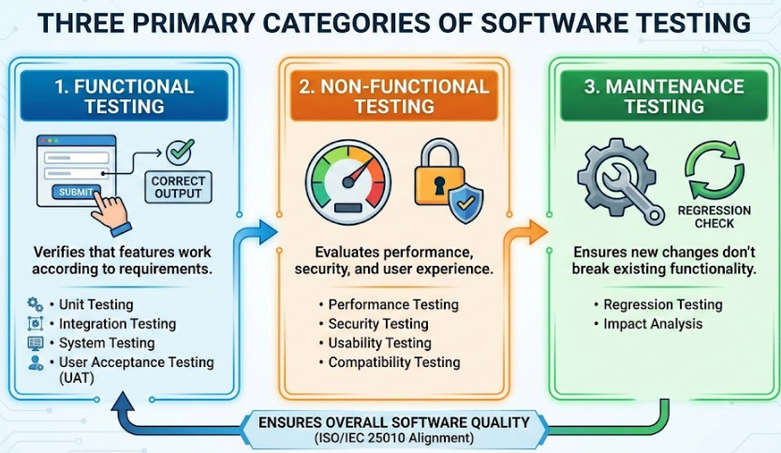

Figure 3. (Primary Categories of Software testing)

Software Quality Evaluation
ISO 25010, titled “Systems and software engineering – Systems and software Quality Requirements and Evaluation (SQuaRE) – System and software quality models”, is a software quality standard. It describes the models, consisting of characteristics and sub-characteristics, for both software product quality, and software quality in use together with practical guidance on the use of the quality models (Britton, 2021).
The quality model is the cornerstone of a product quality evaluation system. The quality model determines which quality characteristics will be considered when evaluating the properties of a software product (ISO 25000, 2021).
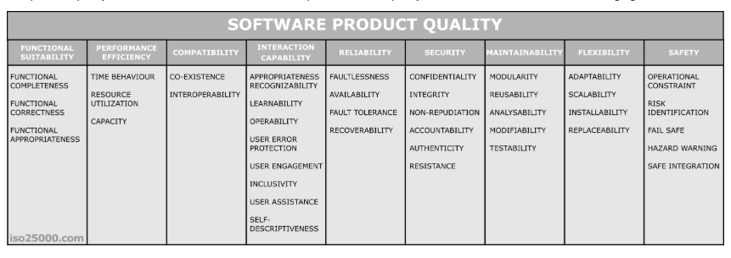
Figure 4. Software Product Quality
ISO/IEC 25010 Product Quality Model standard serves as a comprehensive framework for evaluating software excellence. As illustrated in the figure above, it assesses the quality of a system not just by its code, but by how well it satisfies eight critical dimensions, including functionality, performance, reliability, and security.
Functional Suitability: This characteristic evaluates whether the software actually provides the functions users need to complete their tasks. It ensures that the system’s features align with the user's expectations.
- Functional Completeness: Verifies that the system covers the entire scope of work. It asks: Does the software have all the necessary features to achieve the user’s specific goals?
- Functional Correctness: Focuses on accuracy and precision. It ensures that the system provides the right results (e.g., correct calculations or data retrieval) every time.
- Functional Appropriateness: Measures how well the functions facilitate the accomplishment of tasks. It checks if the features are actually useful and relevant to what the user is trying to do.
Reliability defines the system's ability to maintain a certain level of performance over a specific period. It answers the fundamental question: Can the user trust the system to be available and stable when they need it?
- Maturity: The degree to which the system meets reliability needs under normal, everyday operations without frequent glitches.
- Availability: Ensures the system is operational and accessible exactly when the user needs to access it.
- Fault Tolerance: The system’s ability to keep running smoothly even if a hardware or software error occurs (e.g., preventing a total crash due to a minor bug).
- Recoverability: If a failure does occur, this measures how quickly and effectively the system can restore its data and return to a functional state.
Portability assesses how easily the system can be transferred from one environment to another. This is crucial for ensuring the software works across different hardware, servers, or operating scenarios.
- Adaptability: The ability of the system to adjust effectively to different or evolving hardware and software environments without requiring major changes.
- Installability: Measures how easy it is to install or uninstall the software in its intended environment.
- Replaceability: The degree to which this system can seamlessly replace another specified software product for the same purpose, ensuring a smooth transition for the organization.
Related Studies
“Design and Implementation of a Web-Based E-Recruitment System” by Author Abdulkareem (2023) addresses the persistent issue of traditional recruitment where managing piles of physical resumes leads to data loss and significant delays in hiring. To resolve this, the study developed a centralized web portal that allows applicants to submit their data digitally, ensuring that no candidate information is misplaced. It states that utilizing a web-based platform brought a substantial effect on organizational efficiency, specifically by reducing the "Time-to-Hire" metric. The use of a centralized database helps build up important historical data on the administrator side, allowing HR to track previous applicants easily. In addition, this study provides a solution to the redundancy problem, as the system automatically checks for duplicate applications, ensuring that the company’s resources are focused only on unique, valid candidates.
The “Smart HR: An Automated Candidate Screening and Ranking System” (2022) emphasizes how qualified candidates are often overlooked in mass hiring because HR staff cannot physically read every resume thoroughly. To address the situation we have, the study developed an application which devised a Keyword Matching Algorithm that aids recruiters by automatically scanning applicant inputs against the job description. The added feature of Automated Status Updates is used to run the application and inform applicants of their progress via email notifications. It is proven in this study that the use of automation technology could help HR professionals make shortlisting decisions much easier and more objective, removing human bias from the initial stages.
The Smart HR system used variations of available web technologies and logic that should still be able to communicate between the applicant interface and the admin dashboard: PHP (Hypertext Preprocessor) was used by the researchers as the core backend language, which allows the system to process form data and execute the matching logic dynamically. MySQL Database allows their web application to manage the vast records of applicants and synchronize the status updates in real-time. The application also utilized JavaScript (AJAX) to ensure that the dashboard updates instantly, without requiring the page to be reloaded, allowing recruiters to view new applicants the moment they submit.
“Visualization of Recruitment Data for Strategic Decision Making” by Author Li and Zhang (2024) developed a dashboard module which serves as a medium that helps HR managers visualize their workforce trends. With the help of Data Visualization APIs, it will help track the volume of applicants per department and eventually help managers allocate resources where they are needed most. It is clearly expounded in this study that the use of visual analytics plays a vital role in modern business today, which unexpectedly could help users identify bottlenecks in their hiring process. The application also utilized a Filtering Module to allow users to sort data by date range or specific job positions to get a granular view of performance.
The Visualization System performs as built with the help of modern frontend libraries used for its dashboard to be built based on these components: Chart.js API uses a canvas rendering method for precise graphical representation of its system data, allowing numbers to be converted into line graphs and pie charts. Fetch API was used by the researchers to request data asynchronously from the server, ensuring that the charts load immediately. Date-Range Pickers were also used to filter the reports, allowing the user to generate analytics for specific quarters or months. The Export Module allows an advantage for its data to be downloaded into CSV or PDF formats, which can be used for offline reporting and presentation to upper management.

Conceptual Model of the Study

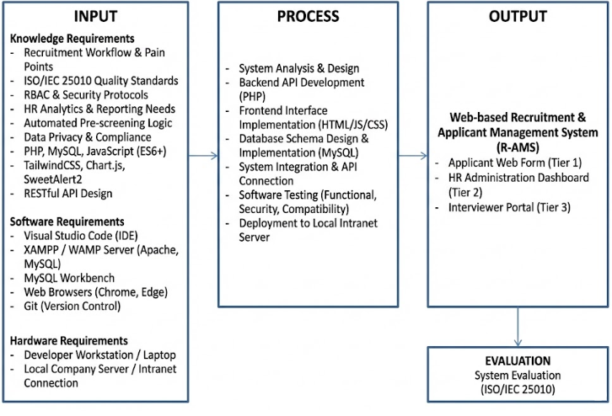
Figure 5. Conceptual Model of the study
The conceptual model will serve as the primary blueprint for the development of the R-AMS. The input phase is split into three main categories: knowledge requirements, software requirements, and hardware requirements, which collectively act as the foundation for development. Knowledge requirements contain the foundational studies and concepts necessary to build the project, including recruitment workflows, automated pre-screening logic, HR analytics, and data privacy protocols. Software requirements cover the specific programming languages and tools needed to code the system, such as PHP, MySQL, JavaScript, Tailwind/CSS, and local server environments like XAMPP. On the other hand, hardware requirements refer to the physical equipment, such as developer workstations and company servers, required to build and eventually host the application.
The process phase represents the actual execution of the software development life cycle, which includes system design and analysis, backend and frontend coding, testing, and continuous improvement. This phase heavily involves structural methods, such as utilizing flowcharts and database schemas based on the gathered input requirements, to map out how applicant data will flow into the HR dashboard. To ensure the overall quality, security, and stability of the software application, the ISO/IEC 25010 software evaluation instrument will be used to thoroughly test and evaluate the system's performance before deployment.
The final output will be the Web-based Recruitment and Applicant Management System (R-AMS). Instead of operating as a single-function tool, the completed project serves as a centralized digital hub divided into three interconnected modules: the Applicant Web Form, the HR Administration Dashboard, and a dedicated Interviewer Portal. By linking these platforms together, the system will successfully automate the tedious pre-screening phase and provides real-time analytics. Most importantly, it streamlines the overall hiring workflow because it directly bridges the communication gap between the HR personnel sorting the applications and the department heads who will actually conduct the interviews.

Operational Definition of Terms

• R-AMS refers to the Recruitment and Applicant Management System, the web-based digital platform developed in this study to automate candidate screening and streamline the hiring workflow.
• Applicant refers to an individual who submits their personal information, skills, and work history through the system's web form to apply for a vacant job position.
• HR Personnel refers to the human resource staff members (Staff or Manager) who manage the recruitment process & review applicant data
• Interviewer refers to the department heads (Manager) or designated assessing staff (HR Staff) who use a separate, restricted portal within the system to evaluate candidates and submit final feedback.
• Pre-screening refers to the initial, automated evaluation phase where the system immediately filters and scores incoming applications based on predefined skills and educational requirements.
• Highly Recommended refers to the pre-screen generated status for applicants who perfectly match or exceed the essential skills and qualifications needed for a specific role.
• Qualified refers to the applicant pre-screen status assigned to candidates who meet the basic, minimum requirements to perform the job but may lack certain advanced or preferred skills.
• Underqualified refers to the pre-screen status of applicants who fall short of the essential criteria, often due to a lack of necessary work experience or educational attainment.
• Review Required refers to the pre-screen applicant whose data needs manual checking by an HR staff member, usually triggered by incomplete entries or unusual skill combinations.
• Archived refers to the secure storage status of applicants who were rejected, did not pass the interviews, or withdrew their applications, kept in the database for future reference.
• HR Dashboard refers to the centralized graphical interface used by HR to view applicant analytics, key performance indicators, and recent system activities at a glance.
• HR Analytics refers to the practice of evaluating recruitment data, such as time-to-hire and applicant volume, to make evidence-based and strategic hiring decisions.
• KPI refers to Key Performance Indicators, the specific, quantifiable metrics displayed on the dashboard that show how effectively the recruitment process is operating.
• RBAC refers to Role-Based Access Control, a security framework ensuring that users, such as HR staff versus Interviewers, can only access the specific section.
• PHP refers to Hypertext Preprocessor, the backend scripting language used to process form submissions, execute the screening logic, and handle server-side operations.
• MySQL refers to the structured relational database system used to safely store and manage all applicant records, interview notes, and registered user accounts.
• JavaScript refers to the programming language used on the frontend to make the web pages highly interactive, such as updating dashboard charts without reloading the screen.
• TailwindCSS refers to a modern, utility-first styling framework used to design the user interface and ensure the application responds seamlessly across different desktop and mobile screens.
• Fetch API refers to a modern web technology that allows the dashboard to request and send data to the server in the background smoothly, preventing annoying page refreshes.
• JSON refers to JavaScript Object Notation, a lightweight data format used to bundle and transmit complex information, like an applicant's work history.
• RESTful API refers to the organized backend architecture that allows different parts of the system, like the web form and the dashboard, to communicate securely and efficiently.
• Chart.js refers to the specific JavaScript library utilized to generate the interactive visual analytics, such as bar graphs and pie charts, found on the HR dashboard.
• SweetAlert2 refers to the tool used to replace standard browser alerts with customizable, interactive popup confirmations to prevent accidental data deletion.
• Litepicker refers to the lightweight date-range tool used in the dashboard that allows users to quickly select specific timeframes when filtering recruitment reports.
• Bulk Upload refers to a system feature that enables HR personnel to import multiple applicant records into the database simultaneously using CSV files, drastically cutting down on manual data entry.
• Smart Filter refers to the advanced search mechanism within the dashboard that allows users to instantly narrow down large lists of applicants by combining multiple criteria, such as date ranges, job positions, and specific recruiters.
• System Logs refers to the automated audit trail that records user actions, system errors, and data modifications to ensure accountability, security, and easier troubleshooting.
• Applied is the default starting status representing a candidate who has just successfully submitted their application through the web form or from bulk upload.
• Failed Speedtest refers to the status of applicants who did not meet the minimum typing test requirement.
• Initial Interview designates the stage where an applicant is currently scheduled for, or undergoing, their first-level assessment (L1) with an HR representative.
• Failed L1 Interview is the status assigned to candidates who were failed on initial Interview.
• Final Interview indicates the critical stage where a candidate has passed the HR screening and is forwarded to the department head or operations manager.
• Failed L2 Interview refers to applicants who successfully reached the final stage of the hiring process but has resulted on failed evaluation.
• For BGV stands for Background Verification, marking the phase where the company actively checks the candidate’s character references, criminal records, and previous employment history.
• Job Offer represents the stage where a successful candidate is officially presented with their compensation package, benefits, and contract terms for review.
• Processing Requirements indicates that a candidate has accepted the job offer and is currently in the process of gathering and submitting their mandatory pre-employment documents (e.g., medical clearances, government IDs).
• Complete Requirements is the status assigned once the HR department has verified and accepted all of the candidate's necessary pre-employment documents.
• Onboarding refers to the orientation phase where the newly hired employee is officially integrated into the company, introduced to workplace policies, and set up with their tools.
• Pooling designates a status for candidates who passed all interviews and assessments but are placed on a standby list until a specific project or job vacancy becomes available.
• Deployed is the ultimate success status in the system, indicating that the hired employee has officially started working on their assigned account or department.
• Withdrawn refers to a status applied when a candidate voluntarily pulls out of the recruitment process.
• Declined Offer indicates that a candidate successfully passed all evaluations and received a formal job offer, but chose not to accept the position.
• Interviewer Dashboard refers to a dedicated, secure interface specifically designed for department heads and assessing managers. This portal allows them to review the profiles of candidates scheduled for final assessments, input their interview notes, and submit their final hiring verdicts without needing full access to the broader HR administrative system.
• Requisition Modal refers to an interactive pop-up window within the application that enables HR personnel to officially add/edit a new job opening or manpower addition. This user interface feature allows them to submit necessary details—such as the requisition ID, Project name, Approved date, and needed headcount—without navigating away from their current web page.
• Recruiters human resource professionals actively utilizing the system to source candidates, facilitate the initial screening and interview stages, and guide applicants through the entire hiring pipeline until they are successfully deployed or archived.

CHAPTER 3

METHODOLOGY
This chapter presents the methodology used in developing the Web-Based Recruitment and Applicant Management System (R-AMS) for XBP Global Company. It discusses the project design, system architecture, interface layouts, database design, development model, operation and testing procedures, and the ISO/IEC 25010-based evaluation process. The methodology ensures that the system is developed systematically and adheres to software engineering standards aligned with the company’s recruitment workflows.

Project Design
This study developed a web-based Recruitment and Applicant Management System (R-AMS) for XBP Global Company to make the entire hiring process faster and more organized. The system can be accessed through any workstation within the company’s intranet, allowing HR staff—such as recruiters, hiring managers, and Department Manager—to securely view, enter, update, and analyze applicant information through role-based dashboards. By centralizing all application data in one place, the platform helps reduce manual errors, speed up processing, and improve tracking of recruitment activities.
Structurally, the R-AMS operates across three distinct but interconnected layers. The first layer is the Applicant Web Form (Tier 1), which serves as the primary entry point for candidates to submit their personal profiles and credentials. Once submitted, the data flows directly into the HR Recruitment Management Module (Tier 2). This module acts as the main command center, allowing HR personnel to efficiently manage candidate records, process bulk application uploads, generate visual analytics, and track all system activities through detailed audit logs. Finally, the system features a dedicated Interviewer Dashboard (Tier 3), providing department heads with a focused, restricted space to review shortlisted candidates assigned to them and submit their final evaluations. To ensure strict data privacy and controlled access, all three of these components are securely hosted within the company’s local network.
The following sections present the System Architecture Diagram, Use Case Diagram, Data Flow Diagrams, Database Design, and UI Layouts for both the applicant interface and the HR system. These diagrams outline how the system works, how data moves through each module, and how users interact with the different features during development.

System Architecture Diagram
The Recruitment and Applicant Management System (R-AMS) includes three major system components: the Applicant User Web Form (Tier 1), the HR Recruitment Management System (Tier 2) and the Interviewer dashboard (Tier 3). The System Design section presents the Context Diagram and Top-Level Data Flow Diagram, which illustrate how system users interact with the main modules and how data flows across the application.
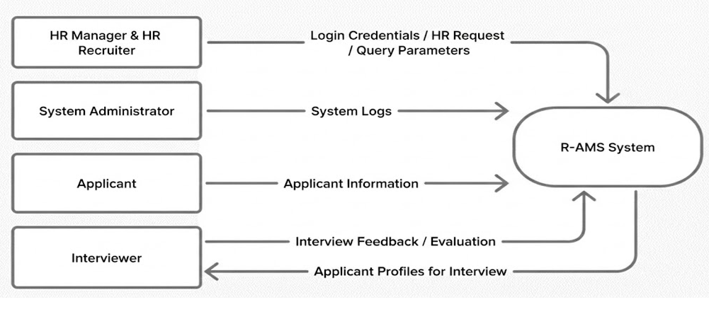
Figure 6: Context Diagram of a developed Web-based R-AMS
Figure 6 shows the Context Diagram for R-AMS, highlighting the interaction between Applicants, HR Recruiters, HR Managers, System Administrators, and the centralized database. Applicants submit their information through the web form, while HR personnel authenticate through the HR dashboard to view, update, and manage applicant records based on their assigned roles and the Interviewer dashboard wherein the Department manager can view the applicant profile and give feedback.
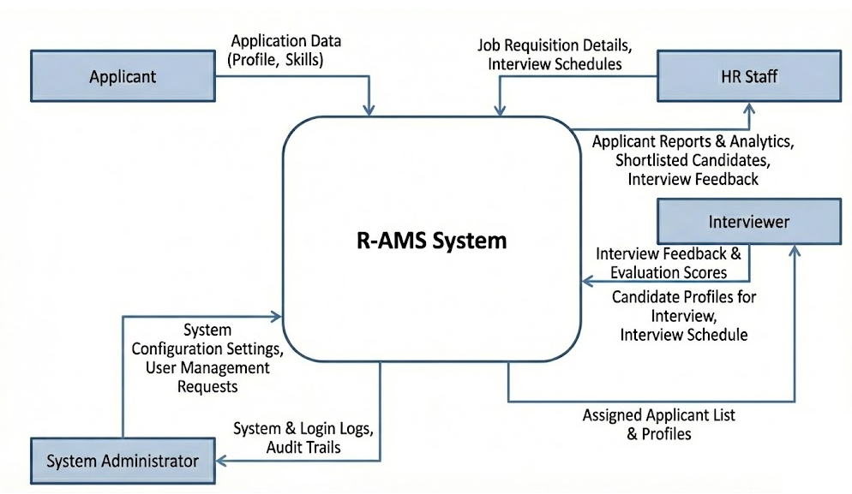
Figure 7: Top level Data Flow Diagram for the development of Web-based R-AMS
Figure 7 illustrates the top-level data flow diagram for the applicants, HR staff, interviewers, and system administrators, which shows their interactions with the centralized recruitment system, application data submissions, and candidate evaluation processes.
Together, these diagrams define the structural and operational design of the R-AMS, showing how users access system modules, how data is processed internally, and how each component integrates to support a streamlined and secure recruitment workflow.

Software Design
The Software Design of the Recruitment and Applicant Management System (R-AMS) presents the system's structural and behavioral components, focusing on user interactions, main services, and their permissions(figure 8). The design centers on a Use Case Diagram that identifies the actors and primary actions the system supports. These diagrams and descriptions guide development and clarify how responsibilities are separated between the applicant-facing interface and the HR administration dashboard.

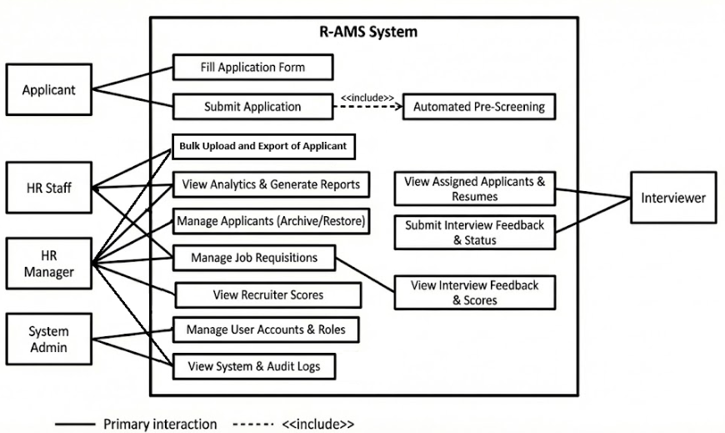

Figure 8: Software design interaction and use cases for R-AMS.
Database Design
The information maintained in the system is illustrated using the MySQL RDBMS (Relational Database Management System) in Figure 9. The RDBMS shows the data of the following: applicant, hr user, and module.
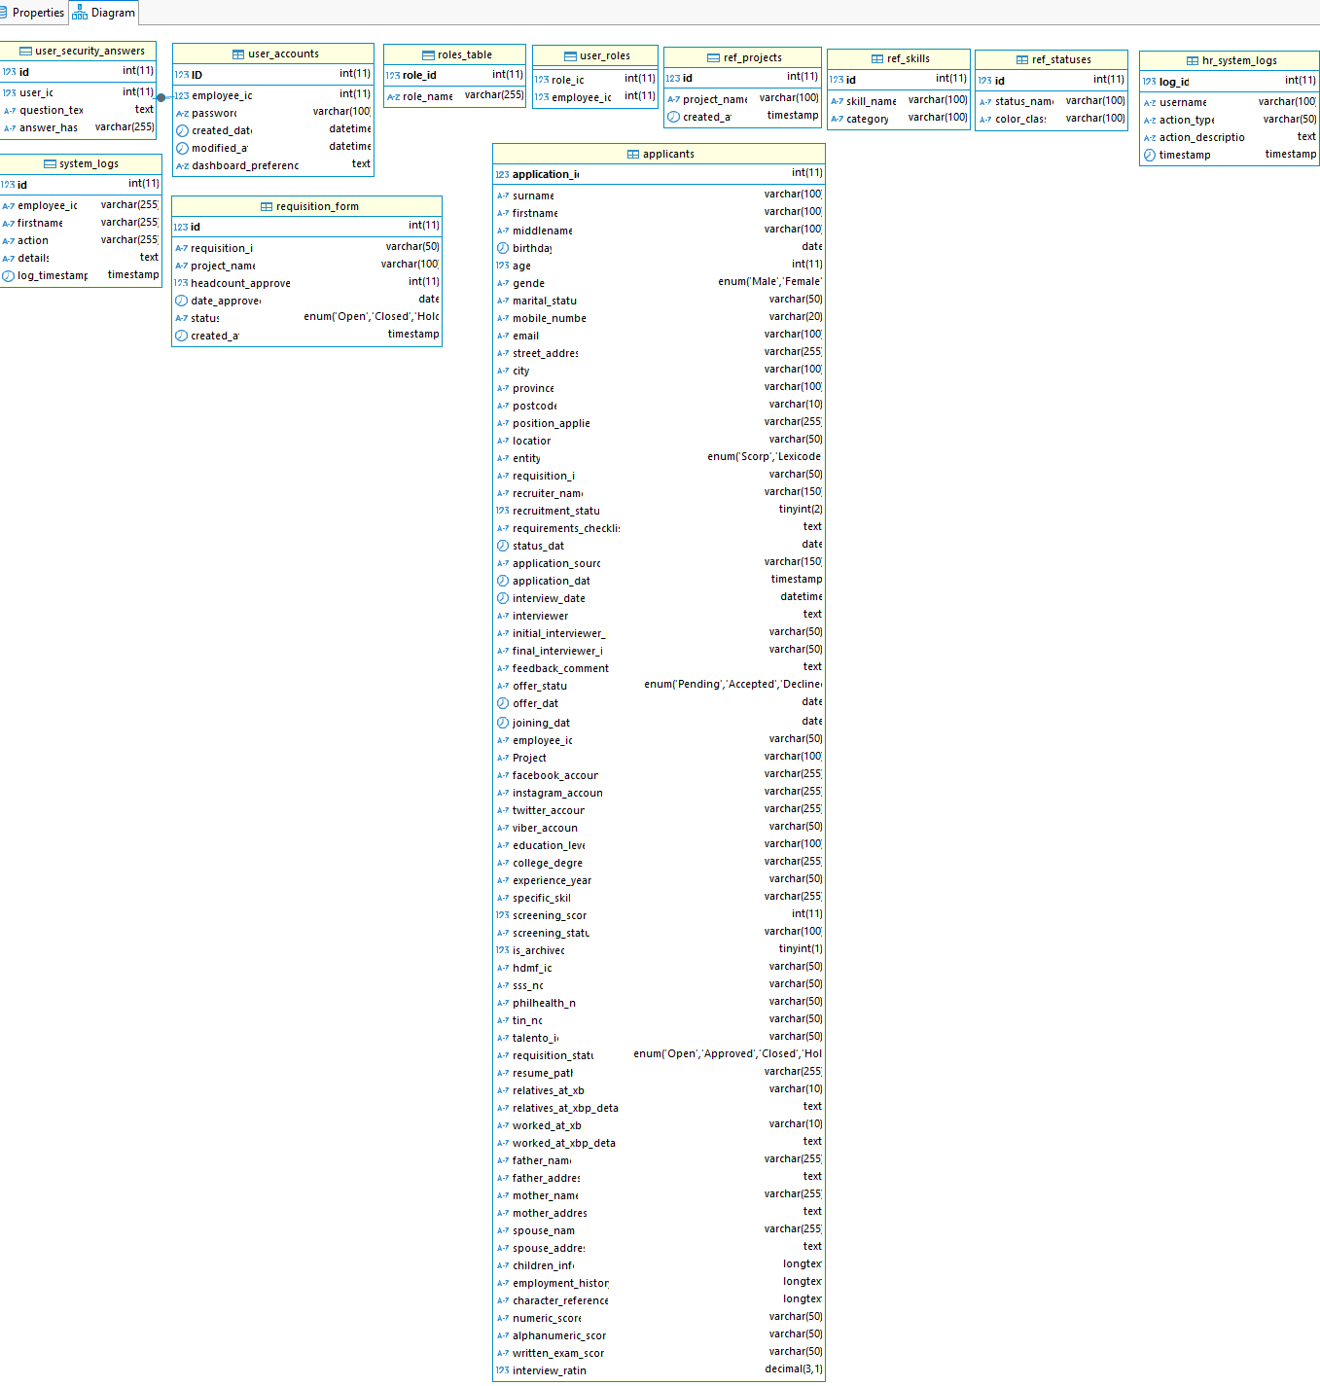
Figure 9: HR User Login, Role permission, other module design for R-AMS

Disaster Recovery and Data Backup To ensure the integrity and availability of the relational database, a Disaster Recovery Plan (DRP) has been implemented. The MySQL RDBMS is configured with a scheduled backup mechanism that automatically saves a copy of the entire database to a designated local administrator desktop. This routine localized backup guarantees that all critical HR data and applicant files can be fully recovered in the event of unexpected hardware or network failures.

System architecture

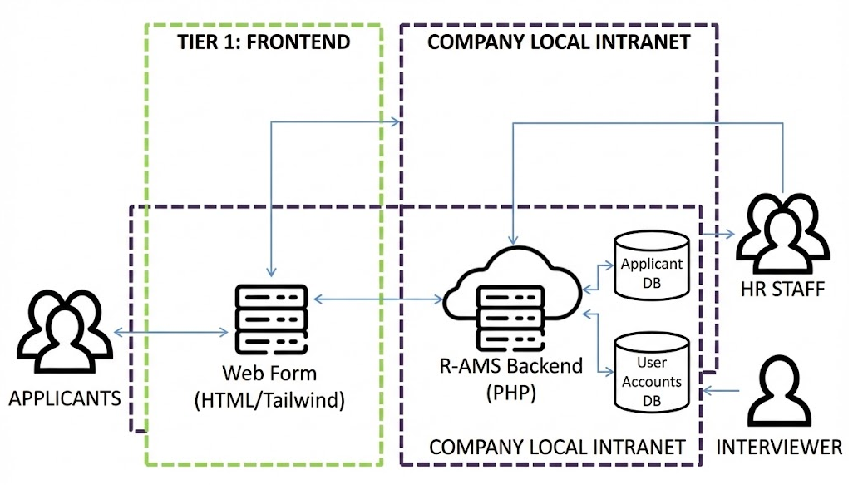
The System Architecture Diagram which displays the communication interface of the system for both the Applicant, Interviewer, HR staff and local server.
Figure 10: System Architecture Diagram for R-AMS
Desktop UI
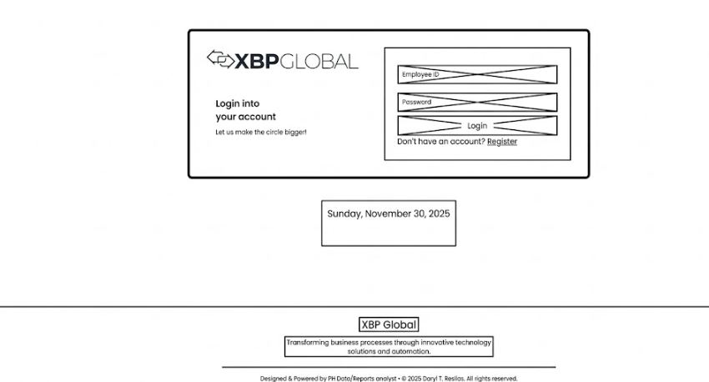

Figure 11: Login on R-AMS
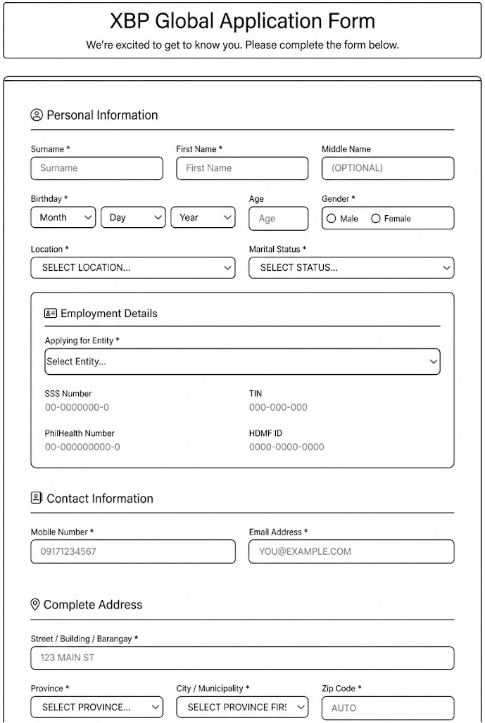

Figure 12: Tier-1 Applicant Form
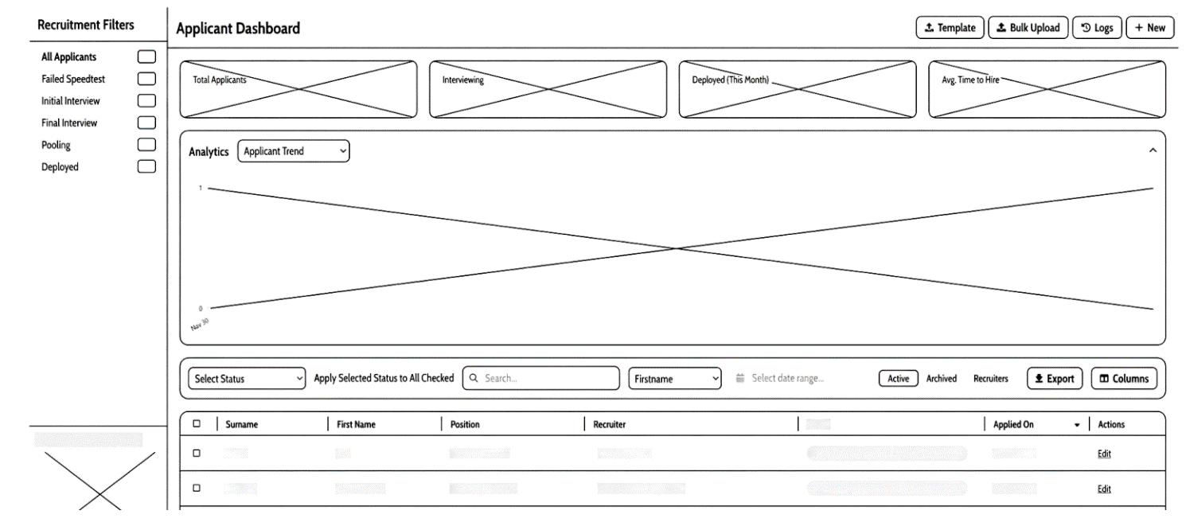
Figure 13: Tier-2 Dashboard Recruitment Active view

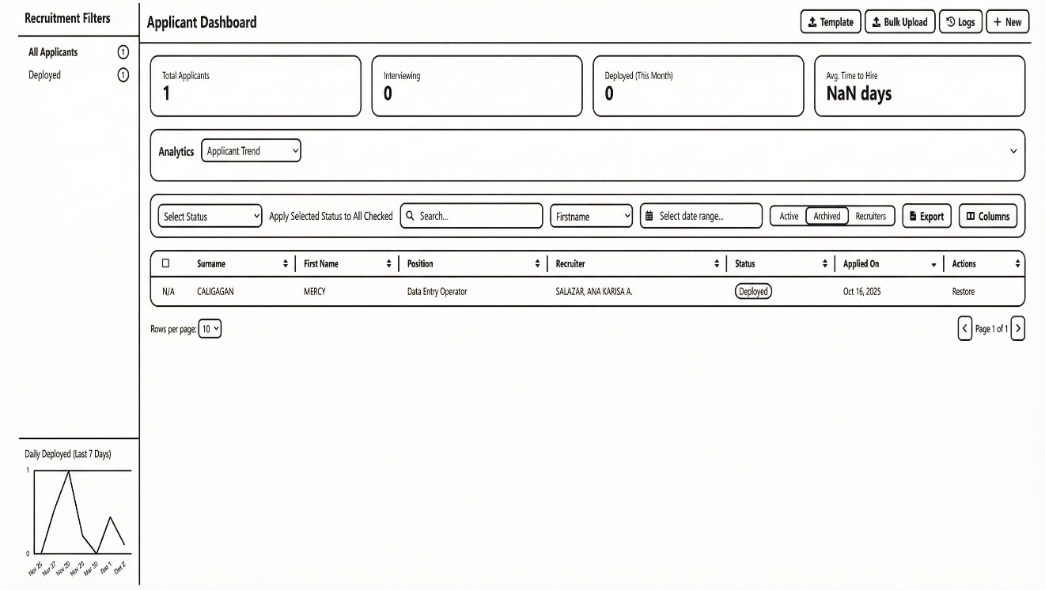
Figure 14: Tier-2 Dashboard Recruitment Active Archived/Restore (chart hidden)

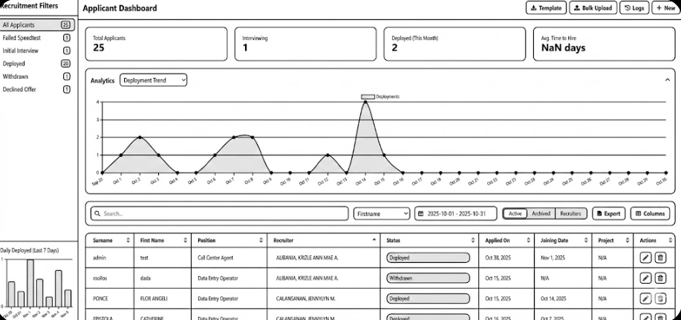
Figure 15: Tier-2 Dashboard Recruitment Active table values

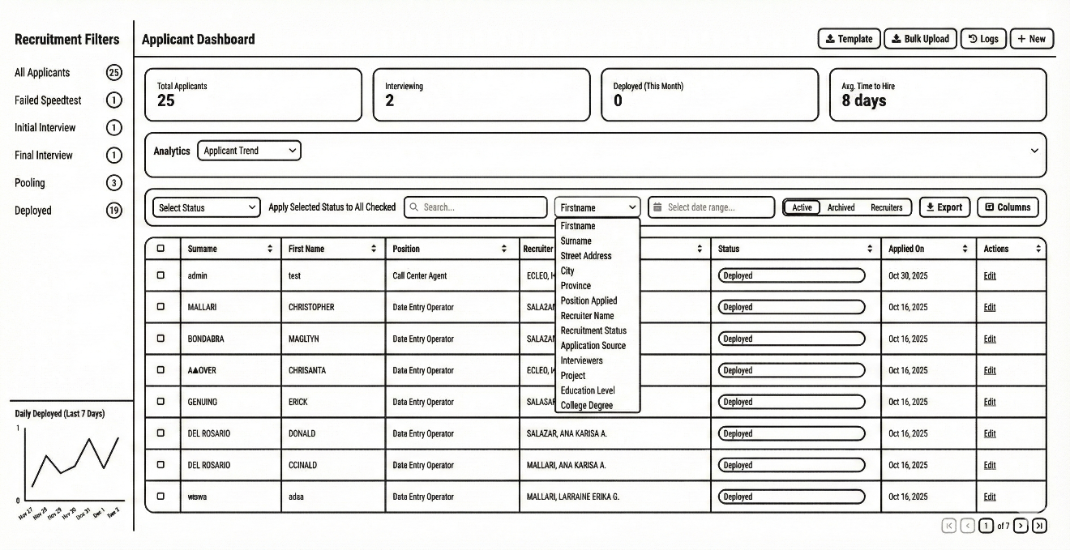
Figure 16: Tier-2 Dashboard Recruitment Active with Table values and search Option dropdown (Chart hidden)

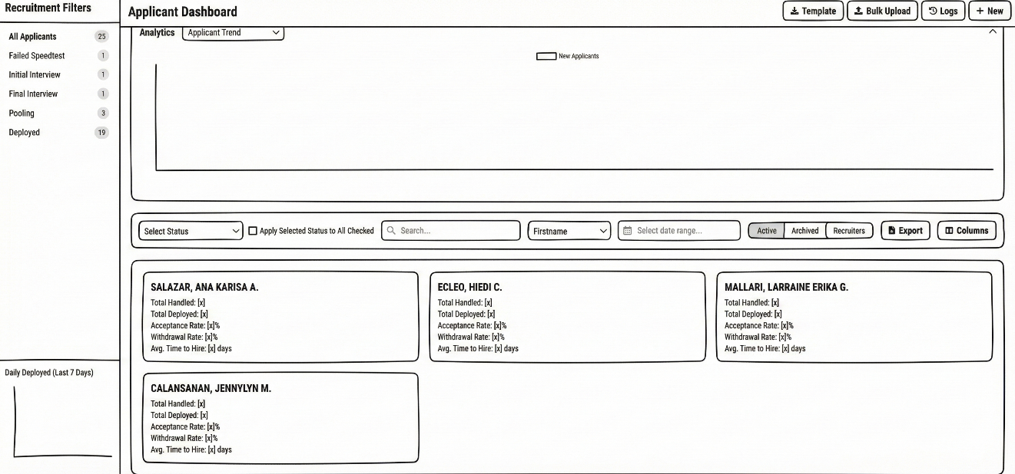
Figure 17: Tier-2 Dashboard Recruitment Recruiter KPI cards

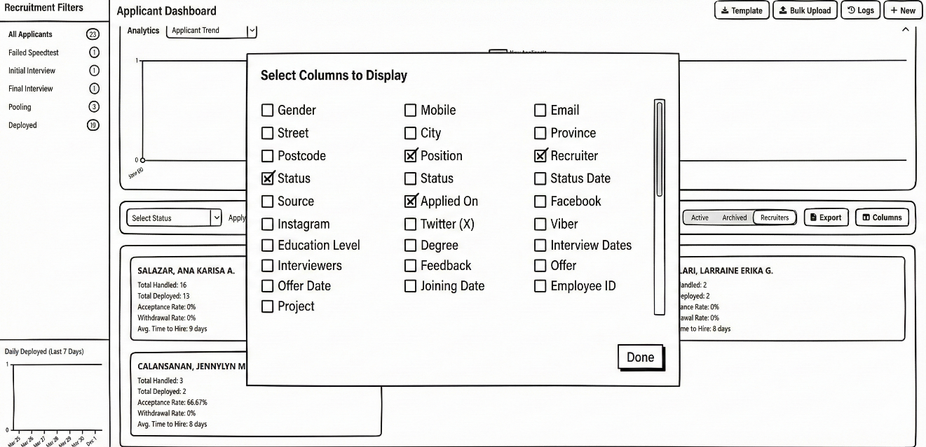
Figure 18: Tier-2 Dashboard Recruitment Column Selection to display
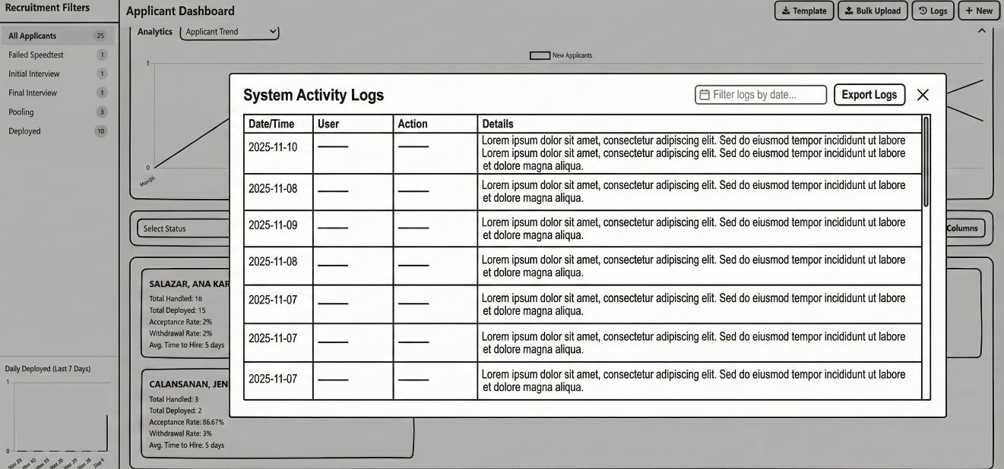
Figure 19: Tier-2 Dashboard Recruitment Activity Logs

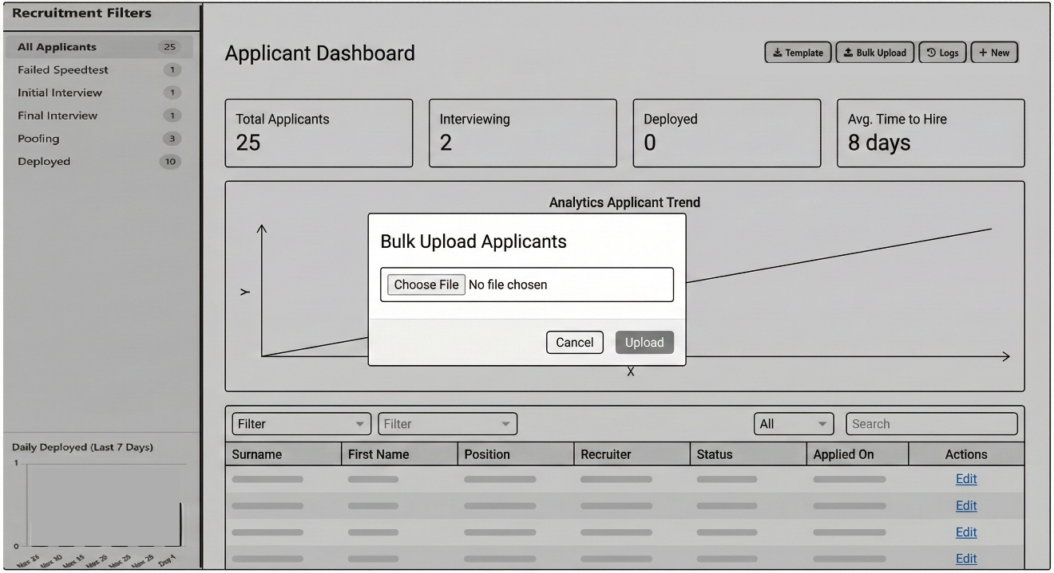
Figure 20: Tier-2 Dashboard Recruitment Bulk Upload Applicants
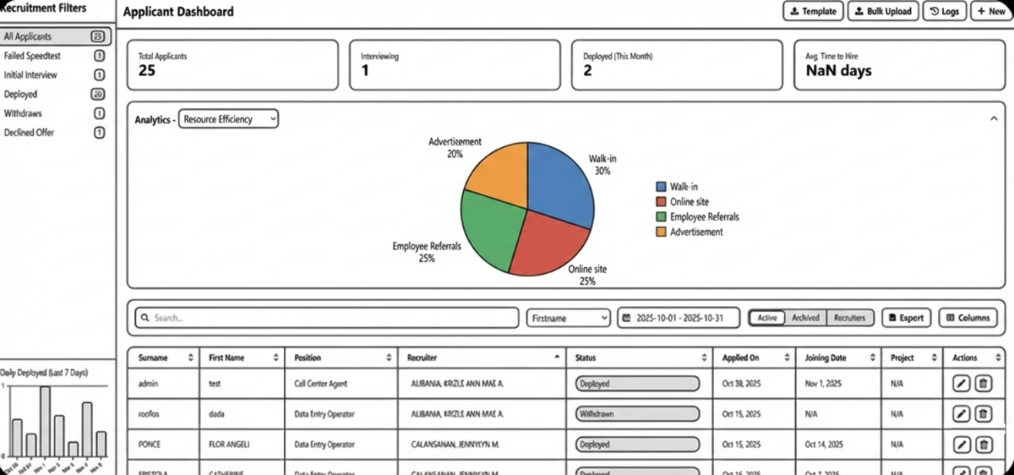

Figure 21: Tier-2 Dashboard Recruitment Analytics = Resource Efficiency



Figure 22: Tier-2 Dashboard Recruitment Analytics = Deployment Trend

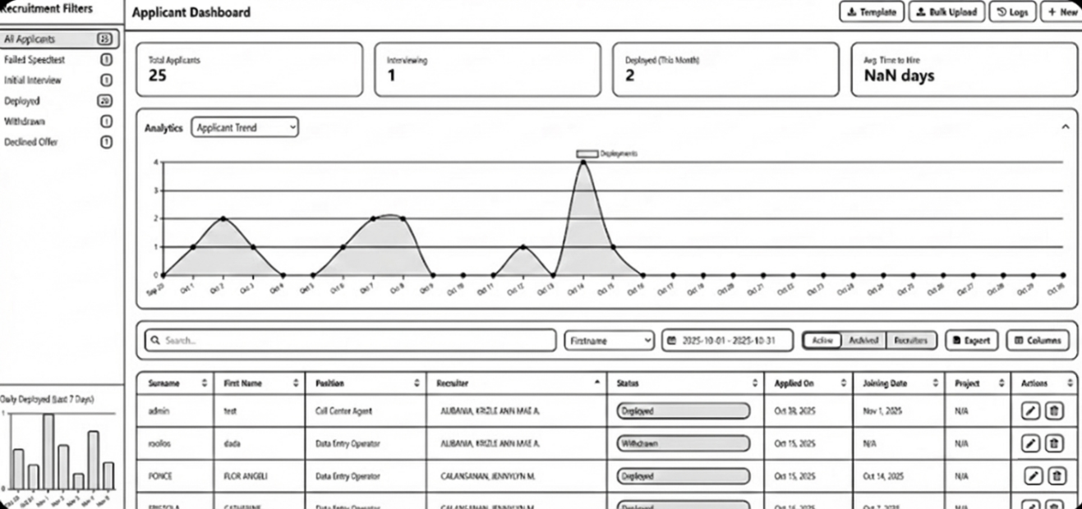

Figure 23: Tier-2 Dashboard Recruitment Analytics = Applicant Trend
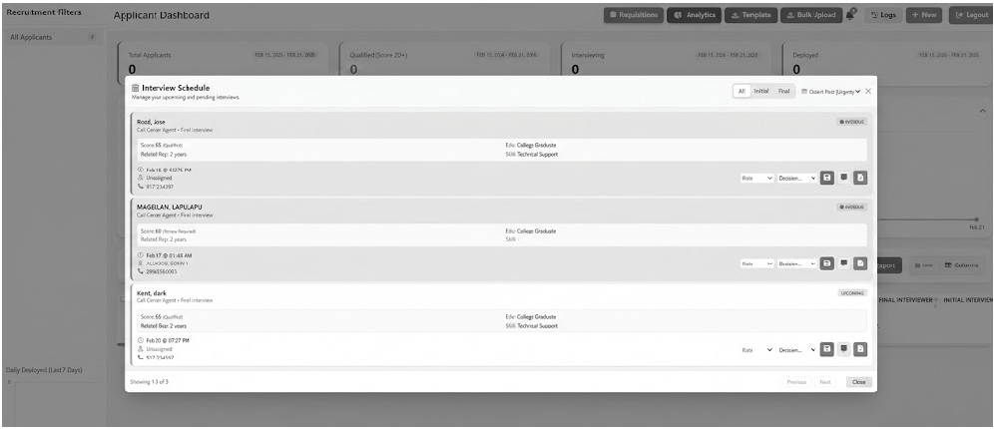
Figure 24: Tier-2 Dashboard Notification for scheduled Interviews

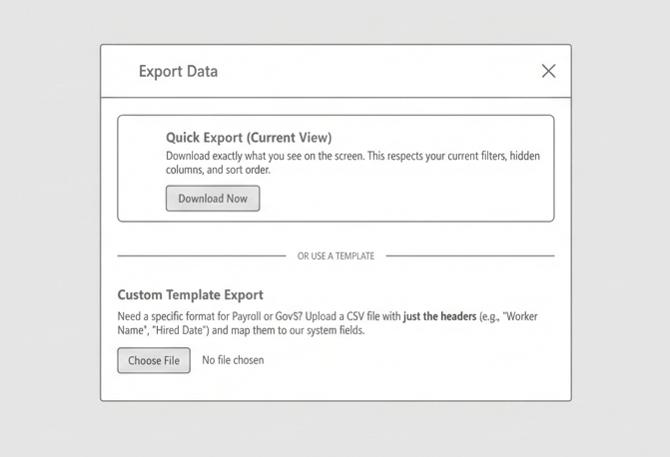
Figure 25: Tier-2 Dashboard Export menu
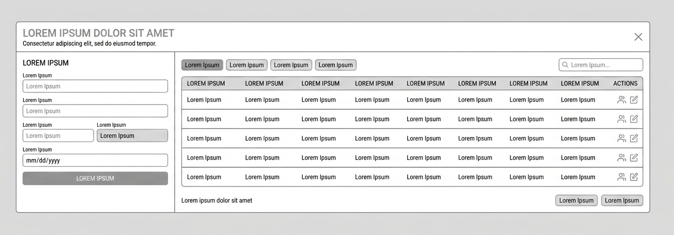

Figure 26: Tier-2 Dashboard Requisition Modal

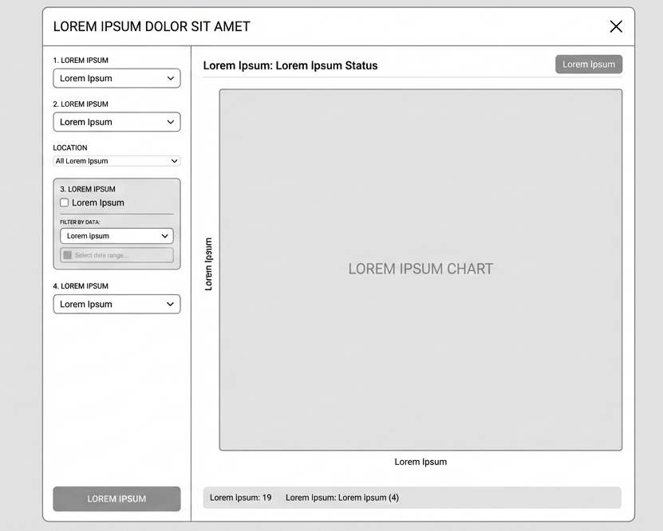
Figure 27: Tier-2 Dashboard Custom Analytics (Bar Chart, Pie Chart, Datasheet)

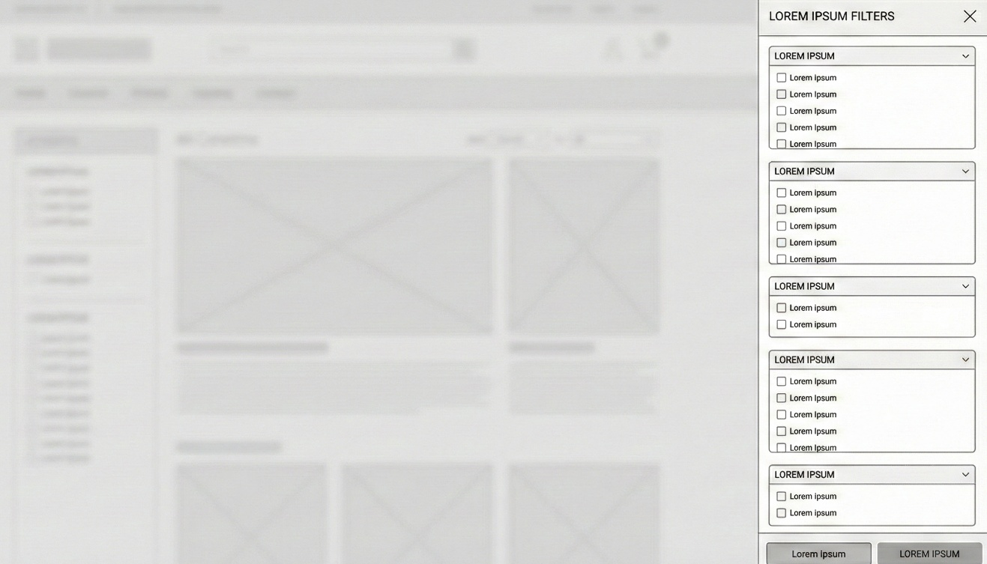
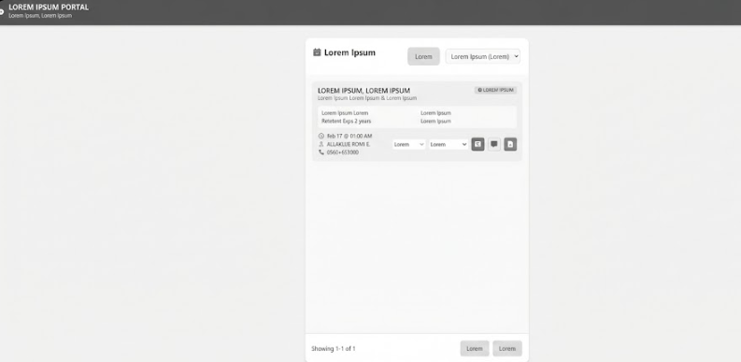
Figure 28: Tier-2 Dashboard Smart Filter

Figure 29: Tier-3 Interviewer Dashboard

Project Development
The Recruitment and Applicant Management System (R-AMS) will be developed using the Iterative Waterfall Model, which allows continuous feedback between phases to improve system quality and correctness. The model consists of Requirement Analysis, System Design, Implementation, Testing, Deployment, and Maintenance, as shown in Figure 30.
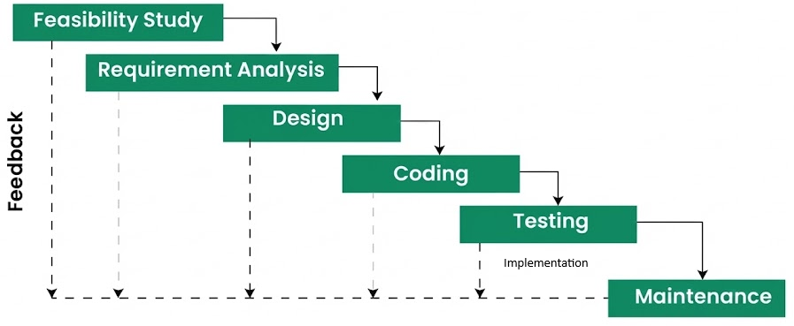
Figure 30: Iterative Waterfall Model

Feasibility Study
This phase evaluated the technical, operational, and organizational feasibility of developing R-AMS. This assessed the availability of required technologies, compatibility with the company’s intranet environment, and the readiness of HR users to adopt a web-based recruitment system.

Requirement Analysis
In this phase, the functional and non-functional requirements of the R-AMS were identified. Existing recruitment workflows were analyzed, and system requirements such as applicant data capture, role-based access control, dashboards, security, and reporting were defined.

Design
The Design phase translated the requirements into system architecture and interface specifications. This included the system structure, database design, data flow diagrams, and user interface layouts for both the applicant form, HR dashboard and Interviewer.

Coding
During the Coding phase, the system will be developed based on the approved design using PHP, JavaScript, HTML, TailwindCSS, CSS, and MySQL. Core modules such as applicant submission, CRUD operations, bulk upload, analytics, and authentication were implemented.

Testing
This phase involved testing the system to ensure correctness, usability, performance, and security. Bugs and issues identified during testing were corrected iteratively, guided by ISO/IEC 25010 software quality standards.

Maintenance
The Maintenance phase ensures the continued reliability and usability of the R-AMS. It includes bug fixes, system updates, performance optimization, and minor enhancements based on user feedback.
Operation and Testing Procedure
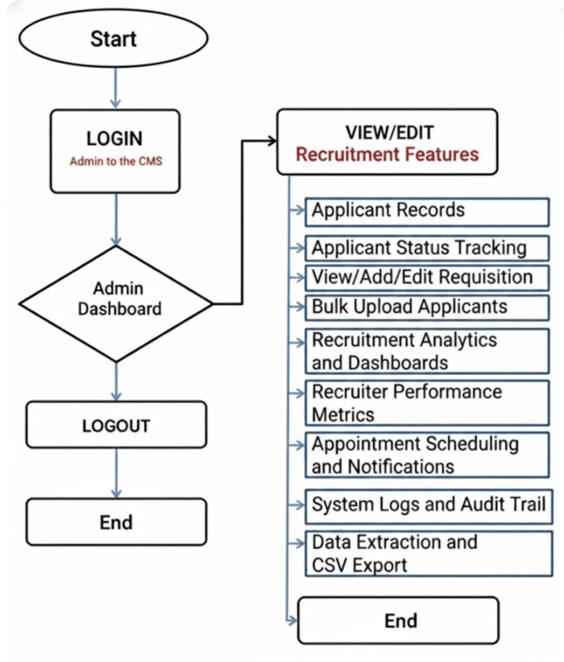

Figure 31: HR Personnel Flowchart
HR Personnel (R-AMS)
- On the web browser, type the local intranet address (URL) of the Recruitment and Applicant Management System (R-AMS) – Tier 2. (Figure 31)
- Enter the administrator username and password to securely access the system.
- Browse the Admin/HR dashboard after successful authentication.
- View or manage the following system features:
  - Applicant Records: View, update, archive, and restore applicant profiles.
  - Applicant Status Tracking: Monitor stages such as pre-screened, interviewed, offered, deployed, or archived.
  - View/Add/Edit Requisitions: Manage job orders, required headcount, and project assignments.
  - Bulk Upload Applicants: Import multiple applicant records simultaneously via CSV.
  - Recruitment Analytics & Dashboards: View real-time charts and visual data on recruitment trends.
  - Recruiter Performance Metrics: Track and evaluate the performance and scores of HR staff.
  - Interview Scheduling: Manage and assign interview schedules to designated interviewers.
  - System Logs & Audit Trail: Monitor user activity, login history, and system changes for security.
  - Data Extraction & CSV Export: Export filtered applicant data or reports for external use.
- After completing the required tasks, log out of the system to end the session.

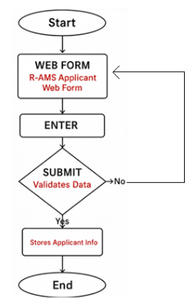

Figure 32: Applicant Flowchart

Applicant
- On a desktop workstation within the company premises, the applicant accesses the R-AMS Applicant Web Form(Tier-1) through a web browser. (Figure 32)
- The applicant fills in the required information such as personal details, contact information, educational background, skills, and other required fields.
- The applicant reviews the entered information to ensure accuracy and completeness.
- The applicant submits the application form.
- The system validates the data and securely stores the applicant information in the centralized database.
- The application process ends, and the applicant waits for further communication from the HR department.
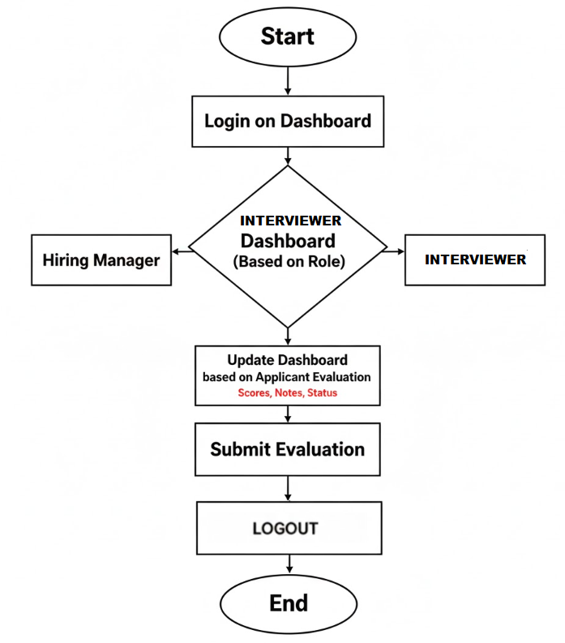

Figure 33: Interviewer Flowchart
Interviewer
- On a secure desktop workstation within the company premises, the Interviewer accesses the R-AMS Admin Portal through a web browser and logs in using their credentials.
- Upon successful login, the system redirects the Interviewer to the Interviewer Dashboard, where the list of assigned applicants is displayed.
- The Interviewer selects an applicant and enters evaluation details, including interview notes, and competency ratings.
- The Interviewer reviews the entered evaluation information to ensure accuracy.
- The Interviewer submits the evaluation. The system validates the required fields and securely stores the records.
- The evaluation process ends, and the Interviewer returns to the dashboard to select another applicant or log out of the system.

Functional Testing
This shall be conducted to verify that all features and functionalities of the (R-AMS) operate according to their specified requirements. This testing ensures that each system module produces the expected output based on defined inputs.
For each development iteration, the following steps were performed:
- Identify the functions included in each software build.
- Prepare test input data based on functional specifications.
- Identify the expected output based on system requirements.
- Execute the defined test cases.
- Compare the actual results with the expected outcome.
- Determine the post condition of the system after execution.
- Evaluate the test case if passes or fails.
The following tables present the functional testing procedures conducted to verify system correctness, portability, and usability.
Portability Testing Procedure

Table 1:

Test Case | Test Environment | Steps Undertaken | Type
Homepage loads correctly | Firefox, Chrome, Edge, Safari | 1. Open browser  2. Enter R-AMS URL | Co-existence
Login page access | Firefox, Chrome, Edge, Safari | 1. Open browser  2. Navigate to login page(based on role) | Co-existence
Applicant Web Form access | Firefox, Chrome, Edge, Safari | 1. Open applicant form URL  2. Load form | Co-existence
Applicant submission | Firefox, Chrome, Edge, Safari | 1. Fill out form  2. Click Submit | Co-existence
Interviewer Dashboard | Firefox, Chrome, Edge, Safari | 1. Open Interviewer dashboard  2. Access assigned Applicant and able to updates | Co-existence
HR Dashboard access | Firefox, Chrome, Edge, Safari | 1. Login as HR user  2. Load dashboard | Co-existence
Applicant Records (CRUD) | Firefox, Chrome, Edge, Safari | 1. View applicant list  2. Create/Edit/Archive/Restore record | Co-existence
Bulk Upload (CSV) | Firefox, Chrome, Edge, Safari | 1. Upload CSV file  2. Validate data | Co-existence
Analytics Dashboard | Firefox, Chrome, Edge, Safari | 1. Open analytics module  2. View charts | Co-existence
Requisition Modal | Firefox, Chrome, Edge, Safari | 1. Open Requisition Modal  2. View/Add/Edit Modal | Co-existence
System Logs | Firefox, Chrome, Edge, Safari | 1. Open logs module  2. View activity logs | Co-existence
CSV Export | Firefox, Chrome, Edge, Safari | 1. Select records  2. Export CSV | Co-existence

Compatibility Testing
Compatibility testing will be conducted to ensure that the R-AMS operates consistently across different devices, operating systems, and browsers. This test verifies that the system produces the same output under varying environments. Please note that R-AMS will not have Mobile set-up since it requires company intranet access.
The following steps were followed:
- Execute the system on different devices and environments (Desktop/Laptops).
- Observe system behavior and record any failures.
- Compare outputs across platforms to ensure consistency.
Compatibility Testing Procedure
Table 2
Test Case | Browser | Steps Undertaken | Type
Access R-AMS Login page | Chrome/Edge/Firefox | Open intranet URL and login | Co-existence
Access R-AMS Dashboard | Chrome/Edge/Firefox | Open intranet URL and login | Co-existence
Access R-AMS Interviewer Dashboard | Chrome/Edge/Firefox | Open intranet URL and login | Co-existence
Access Recruitment Modules | Chrome/Edge/Firefox | Navigate applicant records, dashboards, logs | Co-existence

Usability Testing
Usability testing will be conducted to ensure that the R-AMS provides an intuitive, user-friendly, and accessible interface for both applicant, HR personnel and Interviewer. This test evaluates ease of navigation, clarity of content, and overall user experience.
The following steps were performed:
- Execute the system across multiple browsers and workstation.
- Observe user interaction and task completion.
- Identify usability issues affecting navigation or comprehension.

Usability Testing Procedure
Table 3
Test Case | Steps Taken | Expected Output | Type
Easy navigation | 1. Open homepage  2. Navigate modules | Sections accessible within 1–2 clicks | User Interface
Clear content display | 1. Open forms/pages  2. Review text | Text is readable and structured | Operability
Intuitive layout | 1. Browse dashboard | Menus and buttons are easily identifiable | UI Aesthetics
Applicant form usability | 1. Fill form  2. Submit | Form is easy to complete | Accessibility

Evaluation Procedure
The evaluation of the R-AMS was conducted using descriptive and quantitative methods. A 4-Point Likert Scale was utilized to assess the system’s acceptability based on ISO/IEC 25010 quality criteria.
The following procedure was followed to evaluate the acceptability of the developed system application:
- Selected HR personnel and system users as evaluator-respondents.
- Demonstrated the R-AMS and explained its modules and features.
- Allowed evaluators to use and explore the system.
- Evaluators rated the system using the ISO/IEC 25010 criteria.
- Once demonstration completed, the evaluator respondents were given a questionnaire.
- Tabulated results using Microsoft Excel.
- Interpreted results using the numerical rating scale.

Table 4
4-Point Likert Scale
Numerical Rating | Adjectival Rating
4 | Highly Acceptable
3 | Very Acceptable
2 | Acceptable
1 | Not Acceptable

Chapter 4

RESULTS AND DISCUSSION
This chapter contains the project description, project structure, project capabilities and limitations, and results of evaluation for the project.

Project Description
The study developed a web-based R-AMS designed for company use. The web application, which is developed to assist the company, is particularly for the hiring process.
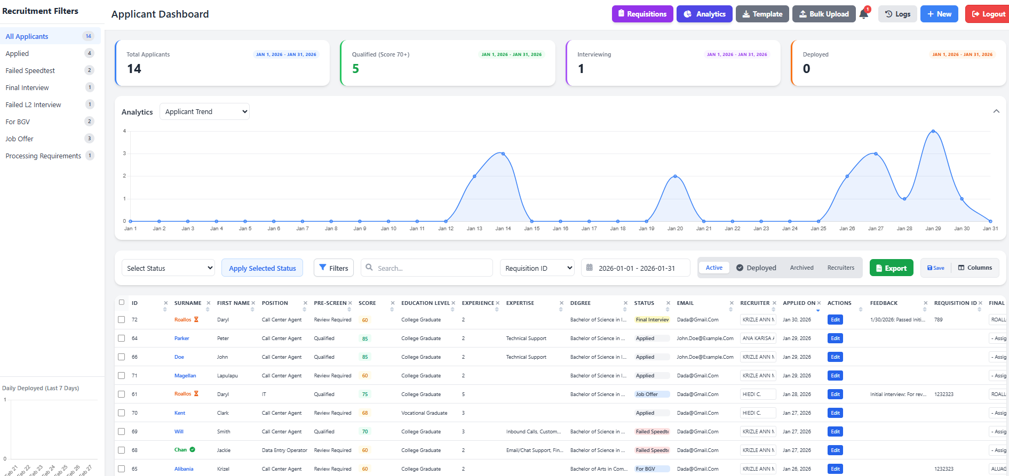
Figure 34: Web application Interface

Project Structure

The web application was designed and developed to be accessible only on web browsers that are accessible via the company intranet.
- The Web Application
The web application, shown on Figure 34, is the Home page interface where features and options are clearly displayed for the user. Here are the major features of the web application:
Figure 35. Applicant Web form – serves as the primary gateway for applicants, wherein they can fill out their information (Personal data, Skills, Educational background, Employment history, etc.). It will automatically calculate a pre-screening score to help HR recruiters shortlist qualified applicants.
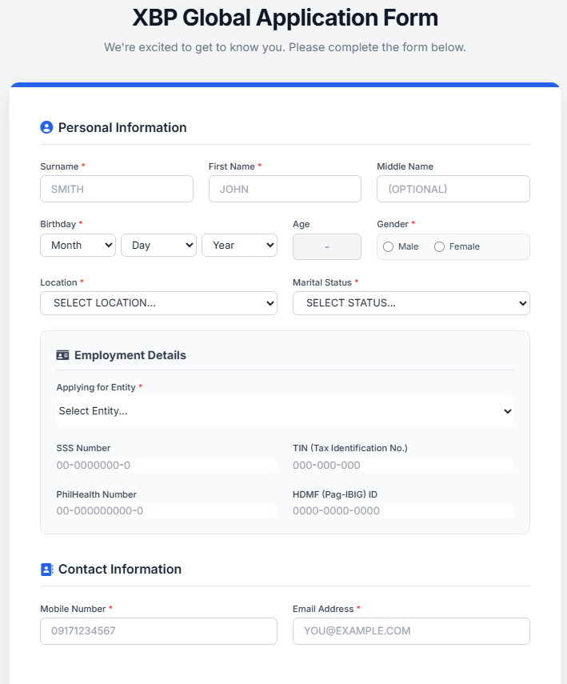

Figure 35: Applicant Web Form

Pre-screening Calculation (Figure 36) – the automated scoring evaluates job applicants submitted form based on four key metrics: Education, Experience, Skills, and position-specific “Hard Gates.”
  - The function has a linear scoring pipeline followed by a validation layer. It will calculate a numerical score (out of 100+) and map it to a qualitative status.
  - The system “Contextual Scoring.” Entry-level roles (e.g., Data Entry, call Center) receive higher points for lower education levels than professionals.
Education Level | Professional Roles | Entry-Level Roles
Post Graduate | 30 pts | 30 pts
College Graduate | 25 pts | 30 pts
Vocational Graduate | 20 pts | 28 pts
Some College | 15 pts | 25 pts
High School Grad | 5 pts | 20 pts

  - Weight is distributed toward tenure; year of experience is the primary predictor of job readiness.
Experience | Points
5+ Years | 50 pts
3 Years | 40 pts
2 Years | 30 pts
1 Year | 15 pts
No Experience | 5 pts

  - Skill Matching (Max 25 points) – The system utilized the Intelligent skill mapping. It compares the applicant's selected skills against a global data option (from the database ref_skills).
• Premium Points (+5): Awarded if the skill category matches the applied position.
• Standard Points (+1): Awarded for general skills.
  - Hard Gate Validation (“Auto-Fail” logic) - This is a critical feature that ensures compliance with industry standards. Even if an applicant has a high score, they are marked as "Underqualified" and their score is reset to 0 if they fail specific criteria:
Position | Required Condition
Nurse | Must be College/Post Graduate + Nursing degree
Accounting | Must be College/Post Graduate + Accountancy degree
Human Resource | Must have HR/Psychology related degree
IT | Minimum Vocational/College + IT/CS/Engineering degree
Medcoder | Requires Medical Coding skill OR medical-related degree
Manager Level | Requires experience (not 0–1 year)
Quality Analyst | Requires prior experience
Procurement | Requires College/Post Graduate
Reports Analyst | Requires experience

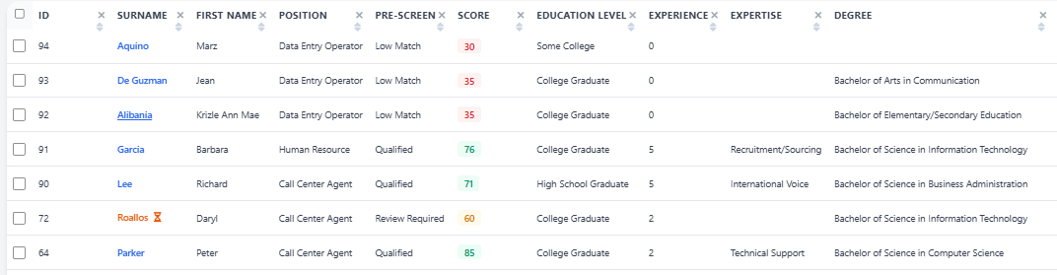
Figure 36: Pre-screening Result

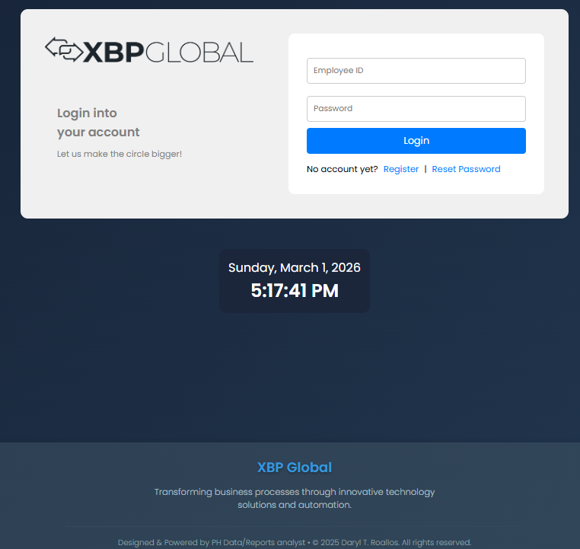
Figure 37. Registration/Login Form – this serves as the Registration and login form of the HR staff and Interviewer. Once they completed the registration, the system admin will update their role mapping as HR Staff, HR Manager or Interviewer. Every role has distinct features.

Figure 37: Registration/Login form
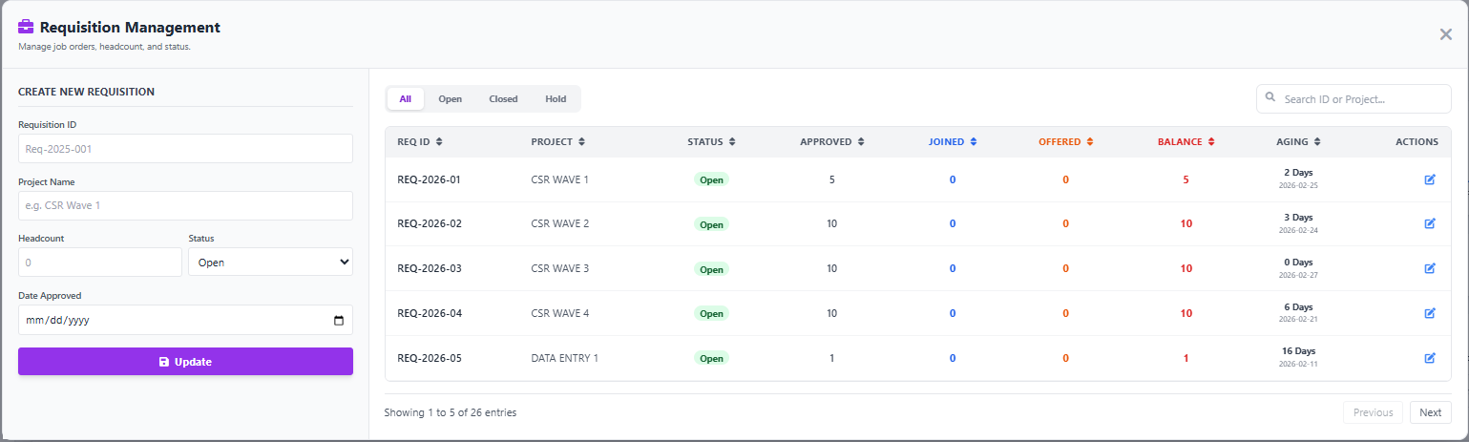
Figure 38. Requisition Management Modal - is a centralized tool for tracking and fulfilling approved headcount requests across various projects. It allows HR and recruitment teams to create new job requisitions, update statuses (Open, Hold, Closed), and monitor the aging of open roles.

Figure 38: Requisition Management Modal

Figure 39. Interviewer Web page – serves as the Appointment section where the Department Managers/Interviewers will see all the assigned applicants to them. This area also allows the interviewer to provide feedback and evaluate the applicant (Passed, Failed or Rescheduled)
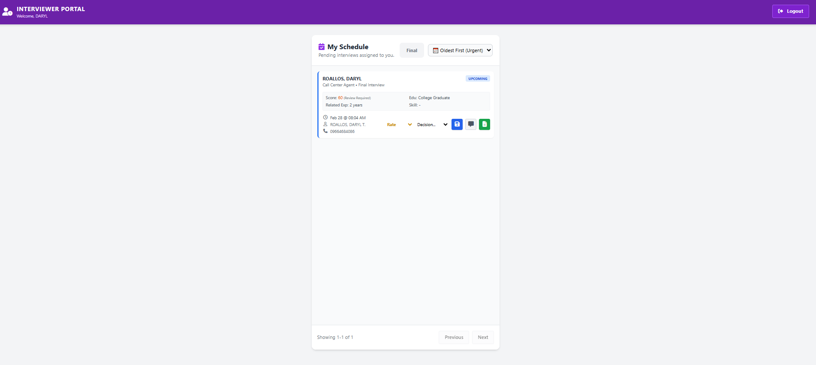

Figure 39: Interviewer Web Page

Figure 40. HR Interview modal viewer – Serves as a viewer for all upcoming or due interviews. It acts as a reminder for HR recruiters to prioritize pending interviews. As the initial interviewer, HR can provide feedback and evaluate the applicant before forwarding them to the Department Manager dashboard for the next stage of the interview.
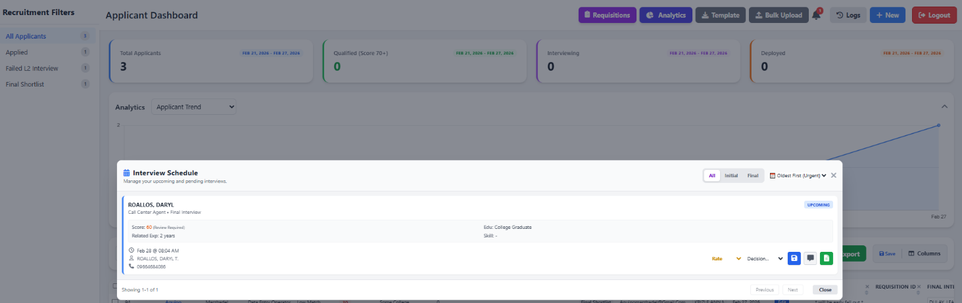
Figure 40: HR Interview Modal viewer

Figure 41-42. Sidebar Recruitment Filter and HR Dashboard table – works as an easy filter for HR recruiters to reflect specific statuses on the dashboard table. Upon click it will instantly filter the HR table based on the selected status. It also helps the user to identify the number of statuses they want to monitor.
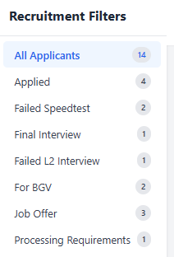

Figure 41: Sidebar Recruitment Filter

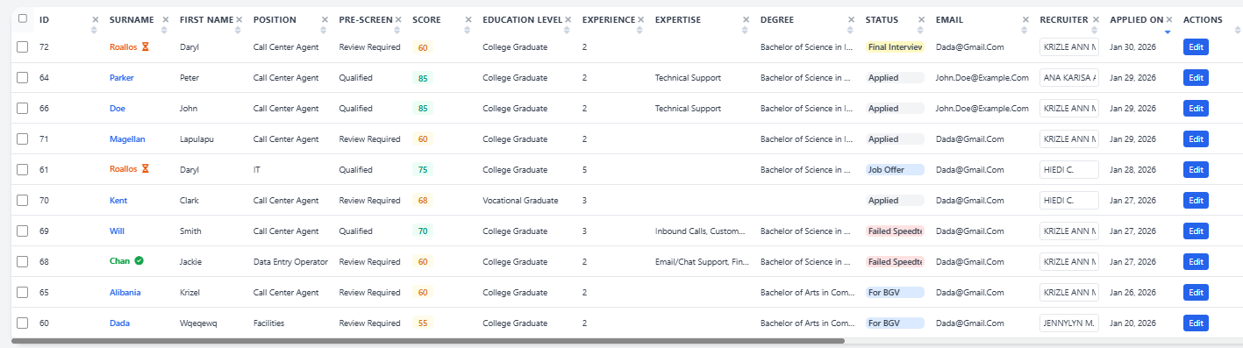

Figure 42: HR Dashboard table

Figure 43. Smart Filter – Allow the user to filter multiple criteria based on their preference.
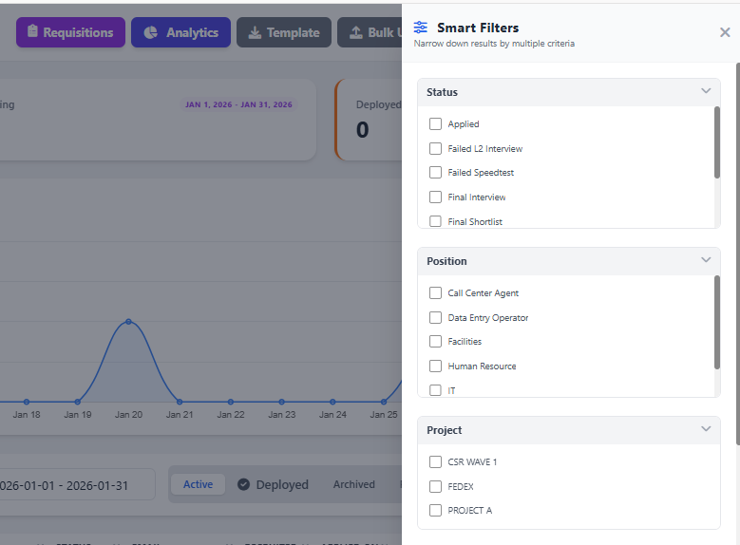
Figure 43: Smart Filter
Figure 44. Cards, Datetime Picker and Quick Analytics – serve as a quick overview for HR recruiters. The cards display the count of applicants based on categories (Total Applicants, Qualified, For Interview, and Deployed). The Datetime Picker acts as a filter, allowing users to select specific or predefined dates. Quick Analytics provides a chart that users can toggle on or off, with the ability to change criteria view.
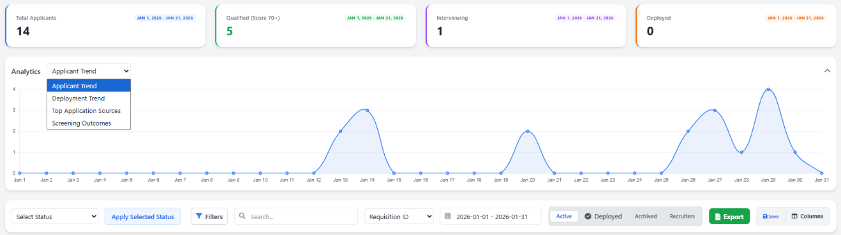
Figure 44: Cards, Datetime Picker and Quick Analytics
Figure 45. System Logs – serve as an audit trail for any actions made on the system of a specific User. This is used to track and maintain user accountability.

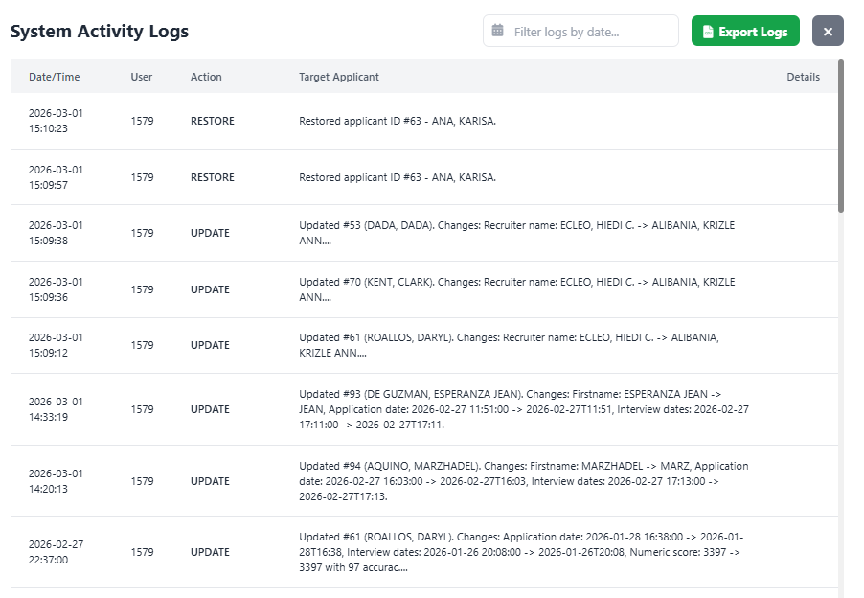
Figure 45: System Logs

Figure 46. Customizable Columns – This will allow the user to customize the columns, by adding or removing their preferred columns.
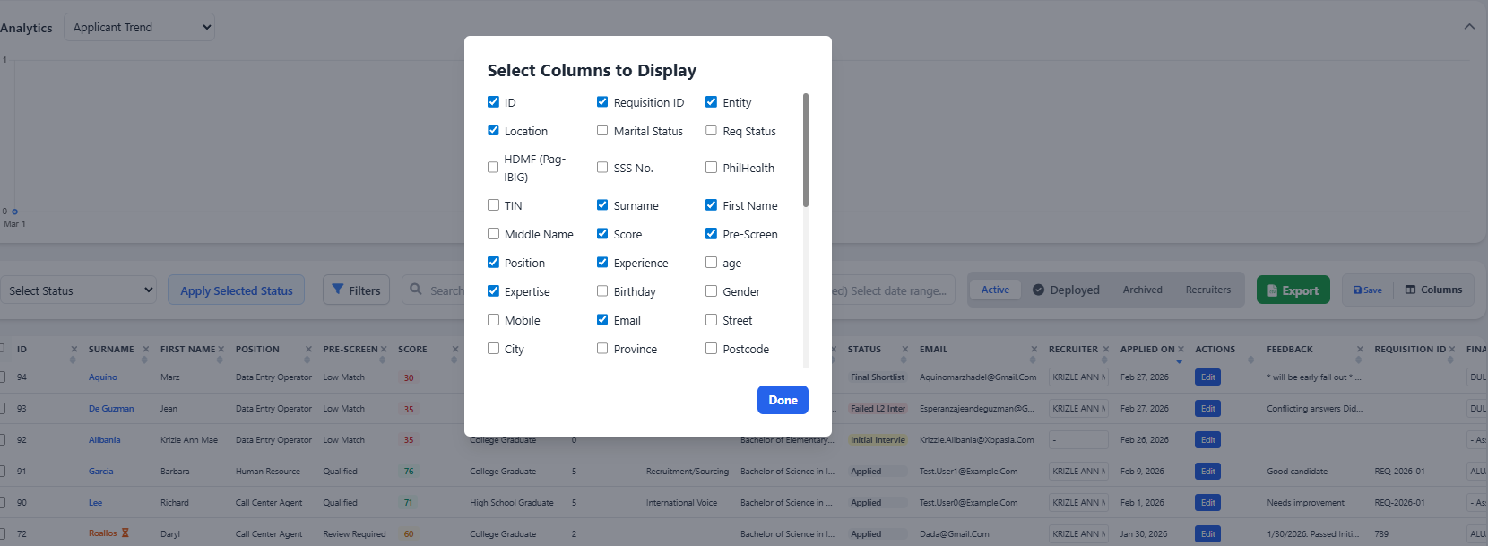

Figure 46: Customizable Columns

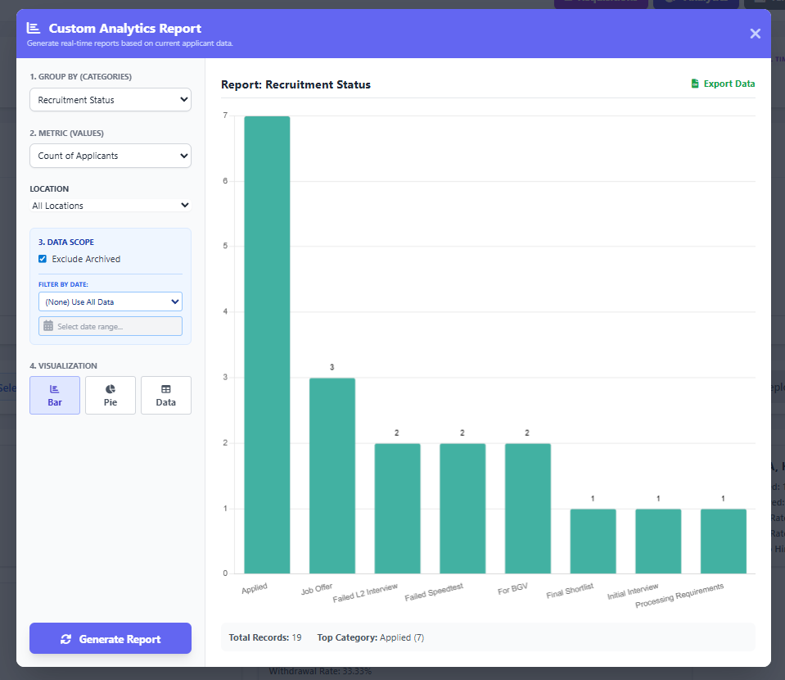
Figure 47. Custom Analytics – This will allow the user to view analytics based on their preferred Categories, Metrics Location and Dates. They can also change the visualization view from Bar Chart, Pie Chart and Data Sheet format.

Figure 47: Custom Analytics Report

Figure 48. Custom Export – This export function acts as a flexible reporting tool. It allows users to export reports based on the data displayed in the HR table or generate reports according to their required format. Users simply need to map their desired headers to the corresponding headers available in the dashboard. They can also save this template on user browser cache and they can use it again whenever they need it.
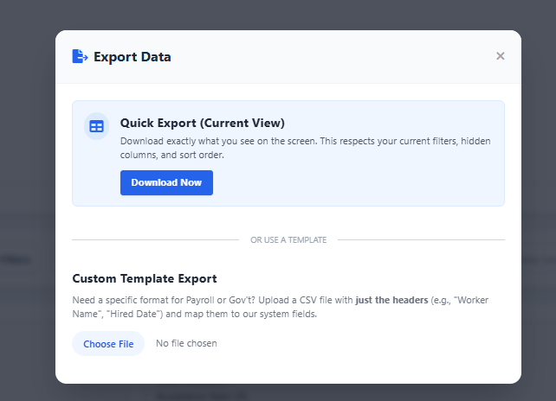

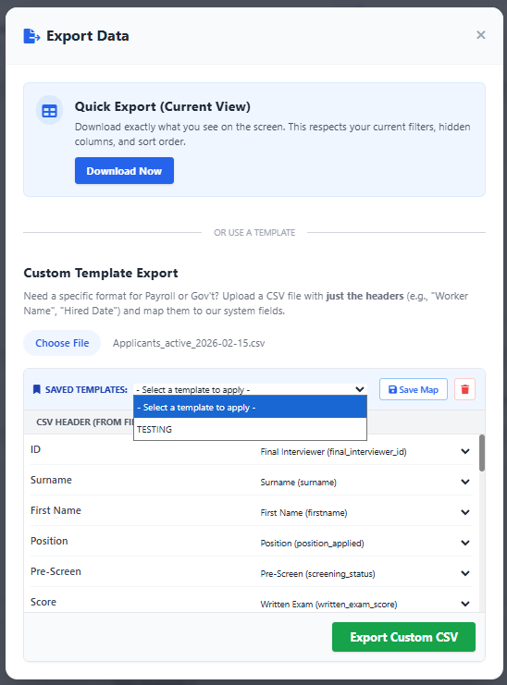

Figure 48: Custom Export

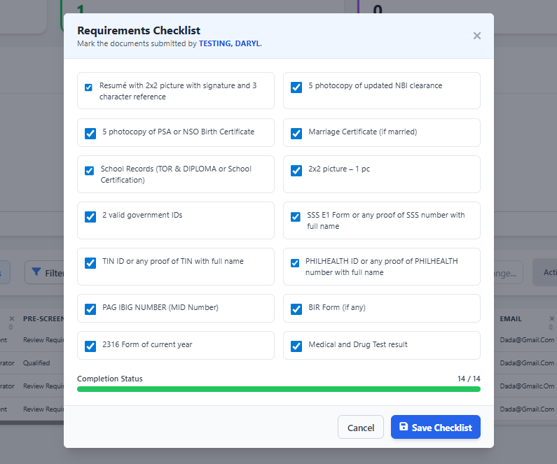
Figure 49. Requirements Checklist – This will serve as a requirement tracker for the HR Recruiter to monitor which documents have and have not yet been submitted.

Figure 49: Requirements Checklist

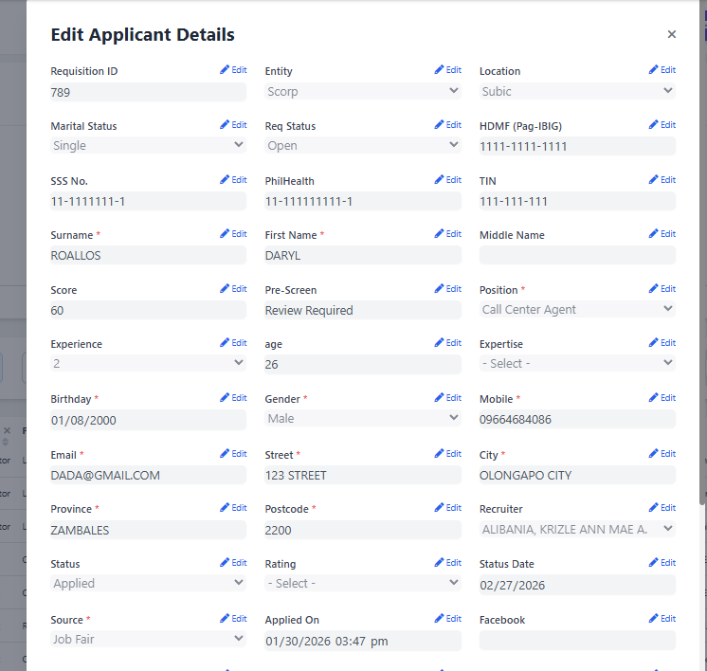
Figure 50. Applicant Edit modal – This serves as the editing section for the HR Recruiter. The data fields are initially displayed as greyed out to prevent accidental modifications. If the user needs to update specific details, they must click the Edit button to enable editing.

Figure 50: Applicant Edit Modal

Project Capabilities and Limitations
Capabilities of R-AMS:
The R-AMS can efficiently process and evaluate high volumes of applicant data. It supports both individual web form submissions and bulk CSV imports, instantly converting raw data into actionable applicant profiles.
1. It includes an advanced search, filter, and analytics feature to help HR staff quickly locate specific applicants and generate real-time reports based on criteria such as recruitment status, location, and application source. Bulk import feature is also included to ensure the HR recruiter be more efficient.
2. The system provides an intelligent pre-screening and automated scoring engine to help HR shortlist the applicants. It also provides a detailed and organized preview of candidate qualifications to ensure recruitment accuracy and achieve faster hiring times.
3. The interface is intuitive. It ensures ease of use and navigation, featuring drag-and-drop customizable column management, Requisition modal and dynamic status updates, with minimal learning required for effective operation.
4. The application implements role-based access control (RBAC), enabling users to access dedicated dashboards and system functionalities according to their assigned roles.

Limitations of R-AMS
The limitations of the application are as follows:
1. The application requires standardized CSV templates during bulk uploads. Unstructured data, highly modified headers, or corrupted date formats may result in import errors.
2. The application is only working on Local Intranet connection and it has No Mobile view.
3. The pre-screening score logic is limited to predefined, objective metrics (such as education level and years of experience). It cannot evaluate subjective candidate qualities—such as cultural fit, attitude, or communication skills—which still require manual human assessment during interviews.
4. No AI feature is currently implemented on the application.

Test Results
The web application was created using HTML, PHP, Tailwind/CSS, MySQL, and JavaScript. As such, the web application can run on any web browser only on a desktop. The test results on the compatibility and usability of the developed system are presented in the following tables.

Table 5.

Compatibility Testing Procedure.
Test Case | Steps Undertaken | Observed Results
(Co-existence) Access the R-AMS Applicant form, HR Dashboard, and Interviewer dashboard from various browsers | 1. Open different web browsers (Google Chrome, Mozilla Firefox, Microsoft Edge, Safari) from a windows PC . | The HR Dashboard, login screen, Applicant Web Form and Interviewer dashboard are displayed correctly and consistently across all modern web browsers.
(Interoperability) The user can interact with complex R-AMS features (e.g., Bulk Uploads, Analytics). | 1. Navigate to the HR Dashboard.  2. Upload a formatted CSV file using the Bulk Upload feature.  3. Adjust filters on the sidebar and click "Generate Report" in the Analytics modal. | The web application successfully processes the CSV file into the database, dynamically updates the applicant table, and renders the pie/bar charts interactively based on user inputs.
(Co-existence) The R-AMS Applicant form, HR Dashboard, and Interviewer dashboard work on the Windows version | 1. Access the HR Dashboard, Applicant web form and Interviewer using a desktop machine. | The system is fully accessible. The HR Dashboard, Applicant Webform and Interviewer dashboard functions optimally only on desktop environments.
(Co-existence) The R-AMS Applicant form, HR Dashboard, and Interviewer dashboard UI respond correctly to various display features. | Click Recruitment filter, Modals, Analytics, and Extract data, Add and remove columns using the desktop machine. | The UI responded correctly to multiple display features. Recruitment filters, modals, analytics, data extraction, and column customization functioned as expected while maintaining consistent table layout and interface stability.

Table 6.

Usability Test Results
Test Case | Steps Undertaken | Observed Results
(Learnability) [HR Dashboard] Uploading Applicant Data via Bulk CSV | 1. Clicked the "Bulk Upload" button on the HR Dashboard.  2. Selected a standard CSV file containing applicant data.  3. Clicked the "Upload" button to process the batch. | The file upload, data parsing (including the automatic date/time fixer), and import functionalities were intuitive and easy to navigate. System responses and progress indicators were consistent.
(Operability) [HR Dashboard] Explore the Applicant Filtering and Search Features | 1. Opened the R-AMS HR Dashboard.  2. Used the sidebar filters to select specific statuses (e.g., "Deployed").  3. Used the search bar to locate an applicant by name or specific skill. | The user successfully applied filters and quickly located specific applicant records. The table dynamically updated without requiring a page reload.
(User Interface Aesthetics) [HR Dashboard] View Analytics and Generated Reports | 1. Opened the R-AMS HR Dashboard.  2. Clicked the "Analytics" button to open the reporting modal.  3. Selected criteria (e.g., Application Source, Location) and clicked "Generate Report."  4. Toggled between Bar, Pie, and Datasheets visualizations. | The Analytics modal displayed clear, visually appealing charts (using Chart.js) and data tables. The interface cleanly presented complex data, such as top applicant sources and status distributions.
(Accessibility) [HR Dashboard] Managing Job Requisitions | 1. User opened the R-AMS HR Dashboard.  2. Fill out the "Requisition Management" module.  3. Created a new requisition, setting a target headcount.  4. Toggled the status of the requisition between Open, Hold, and Closed. | R-AMS provided an accessible, centralized modal to track approved headcount requests against actual deployed candidates, with color-coded badges indicating current capacity.
(Appropriateness/Recognizability) [HR Dashboard] Processing Individual Applicants via the Edit Modal | 1. Open the R-AMS HR Dashboard.  2. Click the "Edit" button on a specific applicant row.  3. Review the candidate's personal data. | The application provided a feature to allow the user to edit applicant information if needed.
(User Error Protection) [HR Dashboard] Display Notification Messages (Login) | 1. Navigate to the R-AMS Login Page.  2. Input an invalid Employee ID or incorrect password.  3. Click the Login button. | The app prevented access and displayed a prompt containing details of the invalid action ("Incorrect Password" or "Employee ID Not Found").
(User Error Protection) [HR Dashboard] Preventing Accidental Data Loss during Edits | 1. User opened the R-AMS HR Dashboard.  2. Clicked "Edit" on an applicant who applied via a custom Application Source (e.g., "TikTok Ads" from a CSV upload).  3. Modified the applicant's status and saved. | The system successfully preserved the custom source data by dynamically injecting it into the dropdown options, preventing the user from accidentally erasing non-standard data.
(Learnability) [Applicant Form] Familiarization with the UI | 1. Applicant navigated to the public-facing R-AMS Applicant Web Form URL.  2. Scrolled through the form sections (Personal Details, Employment, References). | Form sections were logically grouped and clearly labeled. Required fields were distinctly marked, making it easy for applicants with no prior experience to understand the interface.
(Operability) [Applicant Form] Submitting a Complete Application | 1. Filled in all required personal and professional information.  2. Selected the position and dynamic skills from the dropdowns. | The submission process was smooth. The system displayed a loading state and successfully showed a confirmation upon completion. Data instantly routed to the HR Dashboard.
(User Error Protection) [Applicant Form] Mandatory Background Check | 1. Filled in all required fields on the application form.  2. Intentionally left the "Background Check Consent" checkbox unchecked.  3. Clicked "Submit Application." | The browser natively blocked the form submission and highlighted the mandatory checkbox with a requirement prompt, effectively preventing incomplete legal consents.
(Learnability) [Interviewer Dashboard] Viewing Assigned Applicants | 1. Logged into R-AMS using Interviewer credentials.  2. Navigated to the Interviewer Dashboard.  3. Verified the list of applicants displayed on the main table. | The dashboard cleanly filtered out unrelated data, displaying only the specific applicants assigned to that interviewer's ID.
(Operability) [Interviewer Dashboard] Submitting Interview Feedback | 1. Clicked on an assigned applicant's record.  2. Input textual feedback and selected a numerical interview rating (1-5 stars). | The interface allowed the interviewer to easily input evaluation metrics and transition the candidate's status in a few clicks.
(User Error Protection) [System Access] Role-Based Restrictions | 1. Logged in as an Interviewer.  2. Attempted to access HR-specific modules by typing the HR dashboard URL directly into the browser. | The system successfully recognized the user's role_id and prevented access, redirecting the user back to their designated dashboard or showing an unauthorized error.

Evaluation Results

The R-AMS Application was evaluated to determine its acceptability. The respondents consisted of the system beneficiary like our HR Team, company IT professionals, company Interviewer/Manager and external HR personnel who work on the same system as ATS. Table 7 shows the summary of ratings.

Table 7.

Summary of evaluation ratings.

Criteria | Mean | Adjectival Rating
A. Functional Suitability
1. Functional Completeness | 3.71 | Highly Acceptable
2. Functional Correctness | 3.71 | Highly Acceptable
3. Functional Appropriateness | 3.71 | Highly Acceptable
Sub-Mean | 3.71 | Highly Acceptable
B. Performance Efficiency
1. Time Behavior | 3.71 | Highly Acceptable
2. Resource Utilization | 3.86 | Highly Acceptable
3. Capacity | 3.43 | Highly Acceptable
Sub-Mean | 3.67 | Highly Acceptable
C. Compatibility
1. Co-existence | 3.57 | Highly Acceptable
2. Interoperability | 3.71 | Highly Acceptable
Sub-Mean | 3.64 | Highly Acceptable
D. Usability
1. Appropriateness Recognizability | 3.57 | Highly Acceptable
2. Learnability | 3.71 | Highly Acceptable
3. Operability | 3.86 | Highly Acceptable
4. User Error Protection | 3.57 | Highly Acceptable
5. User Interface Aesthetics | 3.71 | Highly Acceptable
6. Accessibility | 3.71 | Highly Acceptable
Sub-Mean | 3.69 | Highly Acceptable
E. Reliability
1. Availability | 3.57 | Highly Acceptable
2. Fault Tolerance | 3.43 | Highly Acceptable
Sub-Mean | 3.5 | Highly Acceptable
F. Maintainability
1. Reusability | 3.71 | Highly Acceptable
2. Modifiability | 3.71 | Highly Acceptable
3. Testability | 3.71 | Highly Acceptable
Sub-Mean | 3.71 | Highly Acceptable
G. Portability
1. Adaptability | 3.71 | Highly Acceptable
2. Installability | 3.71 | Highly Acceptable
Sub-Mean | 3.71 | Highly Acceptable
Grand Mean | 3.66 | Highly Acceptable

In Table 7, the web application obtained its highest sub-mean ratings under "Functional Suitability," "Maintainability," and "Portability," all tying with a sub-mean of 3.71 or "Highly Acceptable”. Specifically, the individual criterion of "Operability" under Usability achieved the absolute highest score overall at 3.86, indicating that the application is easy to control and navigate for the end-users.
The web application obtained its lowest rating under "Reliability" with a sub-mean rating of 3.50, which is still classified as "Highly Acceptable." The individual criteria of "Capacity" and "Fault Tolerance" scored the lowest at 3.43, suggesting minor areas for future scalability optimization, though they comfortably meet current operational standards.
Overall, the system obtained an exceptional grand mean rating of 3.66 or "Highly Acceptable," which means that the developed Recruitment Applicant Management System (R-AMS) successfully addresses its intended requirements and is highly acceptable and beneficial to its intended stakeholders in streamlining the recruitment workflow.
Qualitative Feedback Summary: Evaluators consistently praised the system's intuitive design and direct impact on workflow efficiency. IT and HR professionals highlighted the clean, smooth interface and the straightforward nature of the data/file upload modules. Management and HR end-users specifically commended the system's "roll-out readiness," noting that the searchable database, unique requirements checklist, and automated interview reminders significantly save time, reduce human error, and streamline the overall recruitment process.

Chapter 5

SUMMARY OF FINDINGS, CONCLUSION AND RECOMMENDATION
This chapter presents the summary of findings the conclusions drawn from the findings, and the corresponding recommendations for further enhancement of the project.
Summary of Findings
Based on the evaluation results, the developed web application entitled “Recruitment Applicant Management System (R-AMS)” enables HR professionals, recruiters, and interviewers to efficiently manage, track, and evaluate high volumes of applicants in a centralized platform. The following is the summary of findings using the web application:
- Functional Suitability. The evaluators rated the web application as highly acceptable regarding the application's core functions, such as the automated screening score, bulk CSV data parsing, requisition tracking, and the overall responsiveness of established recruitment objectives.
- Performance Efficiency. The evaluators rated the web application as highly acceptable regarding how the application processes heavy tasks such as rendering real-time Analytics charts and processing bulk uploads.
- Compatibility. The evaluators rated the web application as highly acceptable regarding its interoperability, effectively handling bulk uploads and platform/browser responsiveness.
- Usability. The evaluators rated the web application as highly acceptable regarding how the framework is appropriate for the users' needs. Features like the drag-and-drop table columns, smart filters, visual dashboards, and recruitment sidebar filter which made the system easy to learn, operate, and control.
- Reliability. The evaluators rated the web application as highly acceptable regarding its data availability and fault tolerance, particularly how its role-based access control reliably restricts access to sensitive HR data based on user credentials.
- Maintainability. The evaluators rated the web application as highly acceptable regarding its modular codebase, ensuring that changes or updates to specific components (such as dropdown logic or table structures) have minimal impact on the continued operations of the rest of the system.
- Portability. The evaluators rated the web application as highly acceptable regarding how seamlessly the public-facing Applicant Web Form scales for walk-in applicant, while the complex administrative HR Dashboard and interviewer dashboard runs optimally on standard computer web browsers.
Conclusions The following conclusions were derived from the above findings:
- The web application was successfully designed to have the following features: a. Allows HR staff and Interviewers to navigate an easy-to-use, centralized dashboard tailored to their specific roles. b. Works seamlessly responsive experience for applicants using company dedicated desktops. c. Provides fast loading times for complex data processing, including real-time Chart.js analytics and CSV batch imports. d. Features an intelligent data-cleaning architecture capable of handling unstructured data and standardizing applicant records automatically. e. Works properly on major browsers like Chrome, Firefox, Safari, and Edge with consistent behavior.
- The developed framework was successfully built using PHP, JavaScript (Vanilla, SweetAlert2, Chart.js), Tailwind CSS, and a MySQL Database to ensure a fast, modern, and secure environment.
- The test results show that the web application is fully compatible and highly usable according to the strict requirements of HR stakeholders, recruiters, and applicants.
- The developed web application was evaluated to be Highly Acceptable in all software quality characteristics: Functional Suitability, Performance Efficiency, Compatibility, Usability, Reliability, Maintainability, and Portability.
Recommendations The following are suggestions for further enhancement of the developed web application:
- Improve Interview/Notification System: Integration with calendar applications (such as Google Calendar or Microsoft outlook APIs). This would allow the system notify the interviewer via email instead of only a notification on the Web app which they still need to login.
- AI-Powered Resume Parsing with Resume Upload Capability: Integration of an OCR (Optical Character Recognition) feature that automatically scans uploaded PDF resumes to pre-fill the applicant web form, saving candidates time during application.
3. Integration of an Assessment Module (Paperless Initiative) To further support the organization’s sustainability and paperless initiatives, we are planning to add the Written exams as part Tier of R-AMS. Instead of traditional physical paper-and-pen, applicants can take timed digital assessments through a dedicated web portal. The system would be programmed to automatically grade these examinations and instantly map the results directly to the candidate's profile on the HR Dashboard.

REFERENCES
Bansal, A. (2023). A study of human resource digital transformation (HRDT). Journal of Business Research. https://www.sciencedirect.com/science/article/pii/S0148296322010761
Bratamanggala, R., et al. (2023). Digital transformation in human resource management: A systematic literature review. https://www.researchgate.net/publication/396323318
Britton, J. (2021, May 6). What is ISO 25010? Perforce Software. Retrieved January 5, 2022, from https://www.perforce.com/blog/qac/what-is-iso-25010
Coreflex Solutions. (2024, December 14). Why is software testing important and how does it impact your revenue? Coreflex Solutions.
Hamilton, T. (2021, December 11). What is software testing? Definition, basics & types. Guru99. https://www.guru99.com/software-testing-introduction.html
Hamza, P. A., Othman, B. J., Gardi, B., Sorguli, S., Aziz, H. M., Ahmed, S. A., Sabir, B. Y., Ismael, N. B., Ali, B. J., & Anwar, G. (2021). Recruitment and selection: The relationship between recruitment and selection with organizational performance. International Journal of Engineering, Business and Management, 5(3). https://doi.org/10.22161/ijebm.5.3.1
Helpware. (2025, January 13). ISO 25010: Enhancing our software quality management process. Helpware.
HikeQA. (2025). Importance of security testing in modern software applications. HikeQA.
ImpactQA. (2024). The importance of security testing in the software development lifecycle (SDLC). ImpactQA.
Indium Software. (2023). 7 reasons why software testing is important. Indium Tech.
ISO 25000. (2021). ISO 25000 Portal. iso25000.com. Retrieved January 5, 2022, from https://iso25000.com/index.php/en/iso-25000-standards/iso-25010
Krishna, R., & Verma, A. (2025). Human resource analytics in the digital transformation era. https://www.researchgate.net/publication/393109498
Mahmoud, M. H., Ali, A. A., Alrifae, A., & Abu Eitah, R. (2025). The impact of digital HRM system and digital transformation on HR efficiency. Sustainability. https://link.springer.com/article/10.1007/s43621-025-01713-9
PractiTest. (2024). Software testing costs: Top strategies for efficiency & optimization. PractiTest.
Rahadi, R. A., et al. (2025). Digital HR tools implementation in smart workspaces. https://jtmt.utem.edu.my/jtmt/article/view/6105
Sapizon. (2022). Importance of cost-effective software testing. Sapizon Technologies.
Setyawati, N., Yulianto, A., & Rahman, A. (2021). Web-based management information system for services. http://repository.lppm.unila.ac.id/35595/
Fadhil, H., & Al Husseini, A. (2023). The role of electronic human resource practices in sustainable human resource management. Journal of Management and Business Education, 6(3), 446-470. https://journaljmbe.com/article/view/6107
Hamam, M. H. H., Ahmad, S. Z., & Lim, S. T. (2024). Web-based internship recruitment system with instant notification integration. Journal of Computing Research and Innovation, 10(1), 25-39. https://jcrinn.com/index.php/jcrinn/article/view/492
Junaidi, A. K. (2024). Web-based employee recruitment information system: A design study. Journal of Agriculture, Agribusiness, Welfare, Technology, Humanity, Environment, Social, and Economy. https://jurnal.yayasanmeisyarainsanmadani.com/index.php/AGRONES/article/view/455
Nazreena, R. F. (2023). E-Recruitment strategies for effective recruitment: Perception of recruiters in Chennai region. i-manager’s Journal on Management, 18(1), 37-44. https://doi.org/10.26634/jmgt.18.1.19925
Li, [Initials]., & Zhang, [Initials]. (2024). Visualization of recruitment data for strategic decision making. ResearchGate. https://www.researchgate.net/publication/379499749_BIG_DATA_ANALYSIS_IN_HUMAN_RESOURCES_DECISION_MAKING_OPTIMIZING_WORKFORCE_MANAGEMENT
Ruiz, L., Benitez, J., Castillo, A., & Braojos, J. (2024). Digital human resource strategy: Conceptualization, theoretical development, and an empirical examination of its impact on firm performance. Information & Management, 61(4), 103966. https://www.sciencedirect.com/science/article/pii/S037872062400048X
(2022). Smart HR: An automated candidate screening and ranking system. International Journal of Engineering Research & Technology. https://www.ijert.org/smart-hr-management-system-job-posting-screening-decision-support-ijertv15is010735
Abdulkareem. (2023). Design and implementation of a web-based e-recruitment system. ResearchGate. https://www.researchgate.net/publication/384334475_Technology_acceptance_model_theory_on_intention_to_use_e-recruitment

Appendix A
USER MANUAL
HR Personnel (HR Manager & HR Staff)
- On the web browser, type the local intranet address (URL) of the Recruitment and Applicant Management System (R-AMS).
- Input your Employee ID and password to securely log in.
- The system will automatically authenticate the user role and redirect it to the main HR Dashboard.
- Browse, view, or manage the following recruitment features:
  - Applicant Records: View, edit, archive, or restore individual applicant profiles.
  - Smart Filters & Table: Filter applicants by specific statuses, positions, or recruiters, and customize which columns are displayed.
  - Requisition Management: Create new job orders, update statuses (Open, Hold, Closed), and monitor approved headcounts.
  - Bulk Upload: Import multiple applicant records simultaneously using a standardized CSV file.
  - Analytics Dashboard: View real-time charts (Applicant Trend, Deployment Trend, Resource Efficiency) and generate custom visual reports.
  - Data Extraction: Map specific headers and export filtered applicant data to CSV formats.
  - System Logs: Review the audit trail of recent user activities and data changes.
- After completing the required tasks, click "Logout" to end the session securely.
Interviewers (Department Managers)
- On the web browser, type the local intranet address (URL) of the R-AMS.
- Input your Employee ID and password to log in.
- The system will recognize your specific role and redirect you to the restricted Interviewer Dashboard.
- View your pending and upcoming assigned interview schedules.
- Click on an assigned applicant to securely review their pre-screening score, profile details, and uploaded resume.
- Input your evaluation details, including specific interview feedback, and a 1-5 star competency rating.
- Submit the evaluation and update the applicant's final decision status (e.g., Passed, Failed, Rescheduled).
- After completing your evaluations, click "Logout" to end the session.
Applicants
- On the company workstation, type the URL of the R-AMS Applicant Web Form in the browser.
- Fill out the required information, including Personal Details, Contact Information, Educational Background, and Specific Skills.
- Check the mandatory consent box acknowledging the background verification terms.
- Review the entered information carefully to ensure accuracy and completeness.
- Click "Submit Application".
- Wait for the success prompt; the system will instantly calculate your pre-screening score and securely route your information to the HR department.

Appendix B

COMPATIBILITY TEST RESULTS

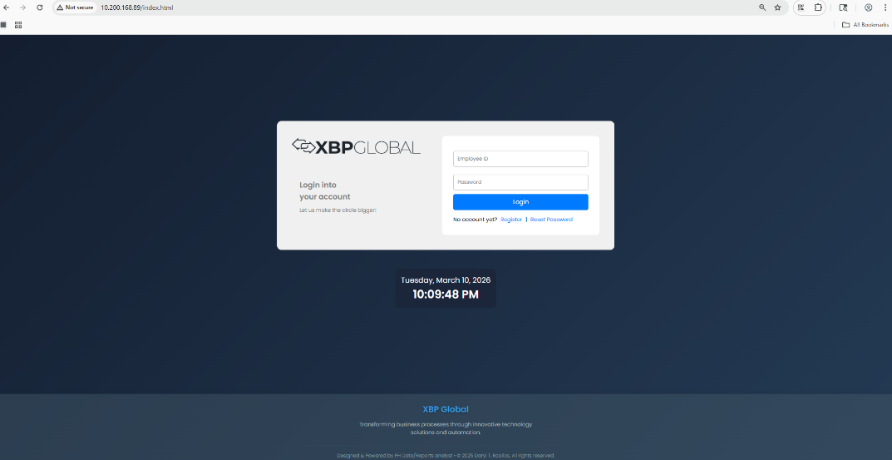
Desktop View (HR/Interviewer Login form)

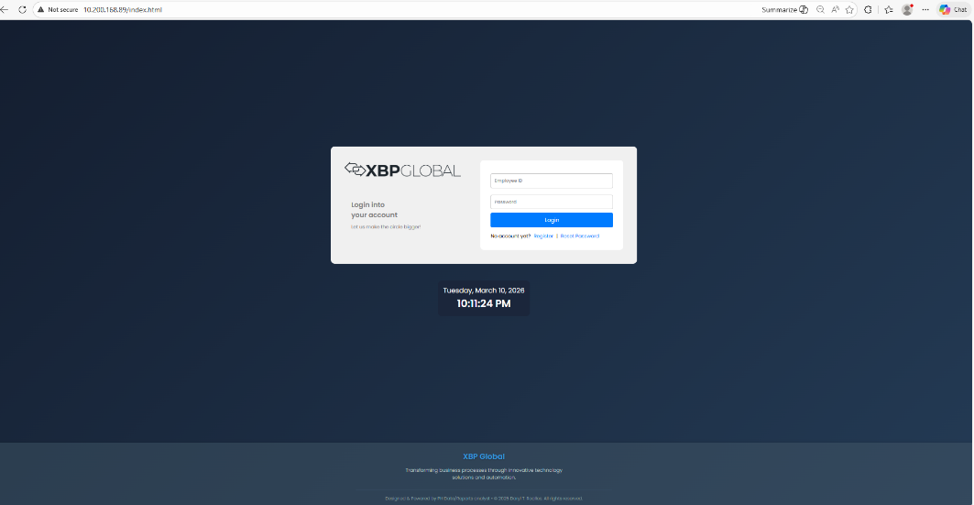
Figure 51: Google Chrome

Figure 52: Microsoft Edge
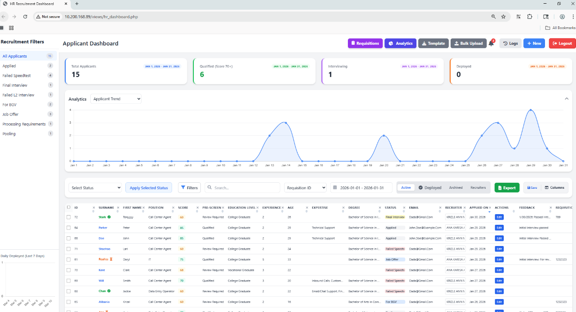
Desktop View (HR Dashboard)

Figure 53: Google Chrome
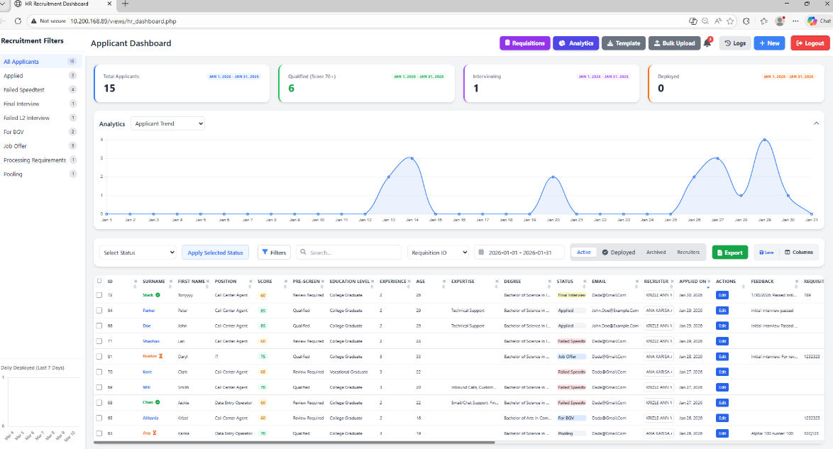

Figure 54: Microsoft Edge
Desktop View (Interviewer Dashboard)
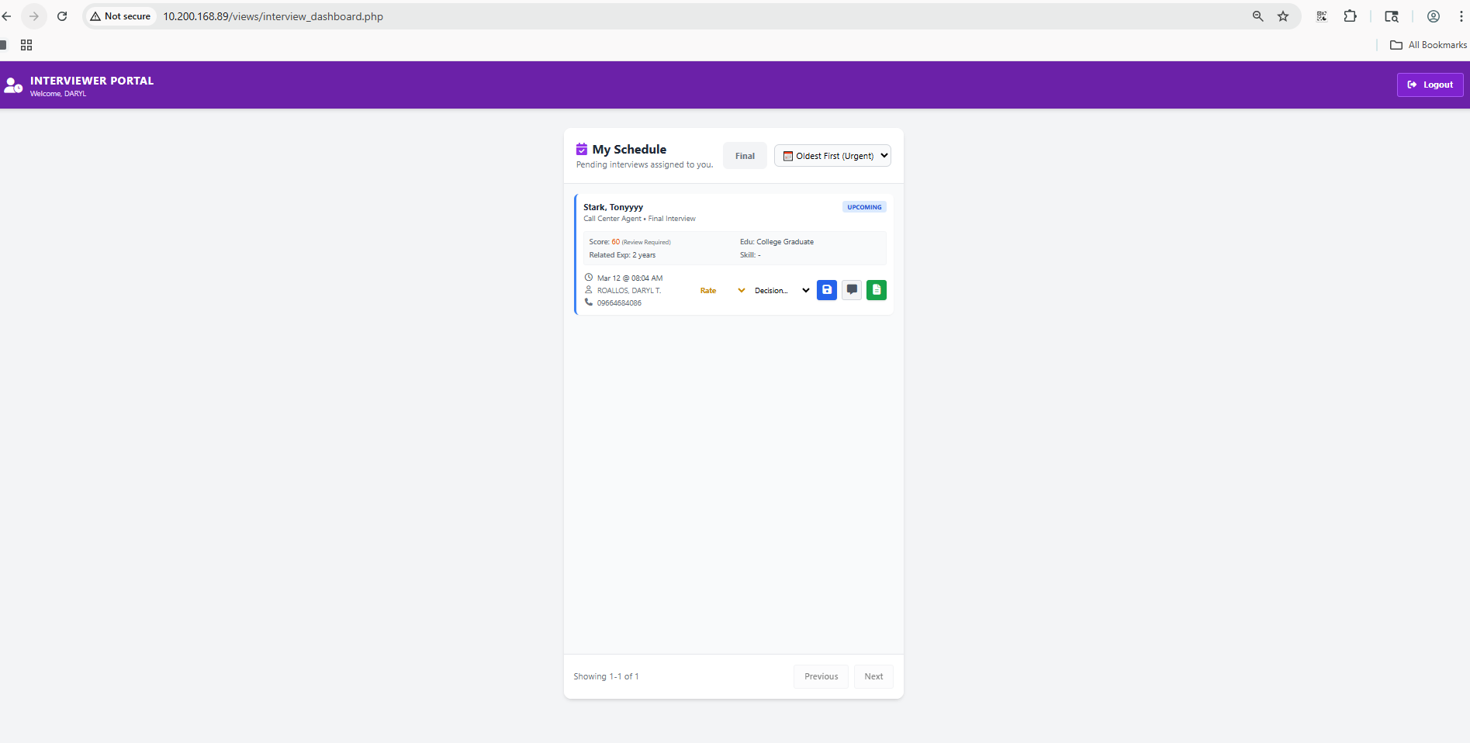
Figure 55: Google Chrome
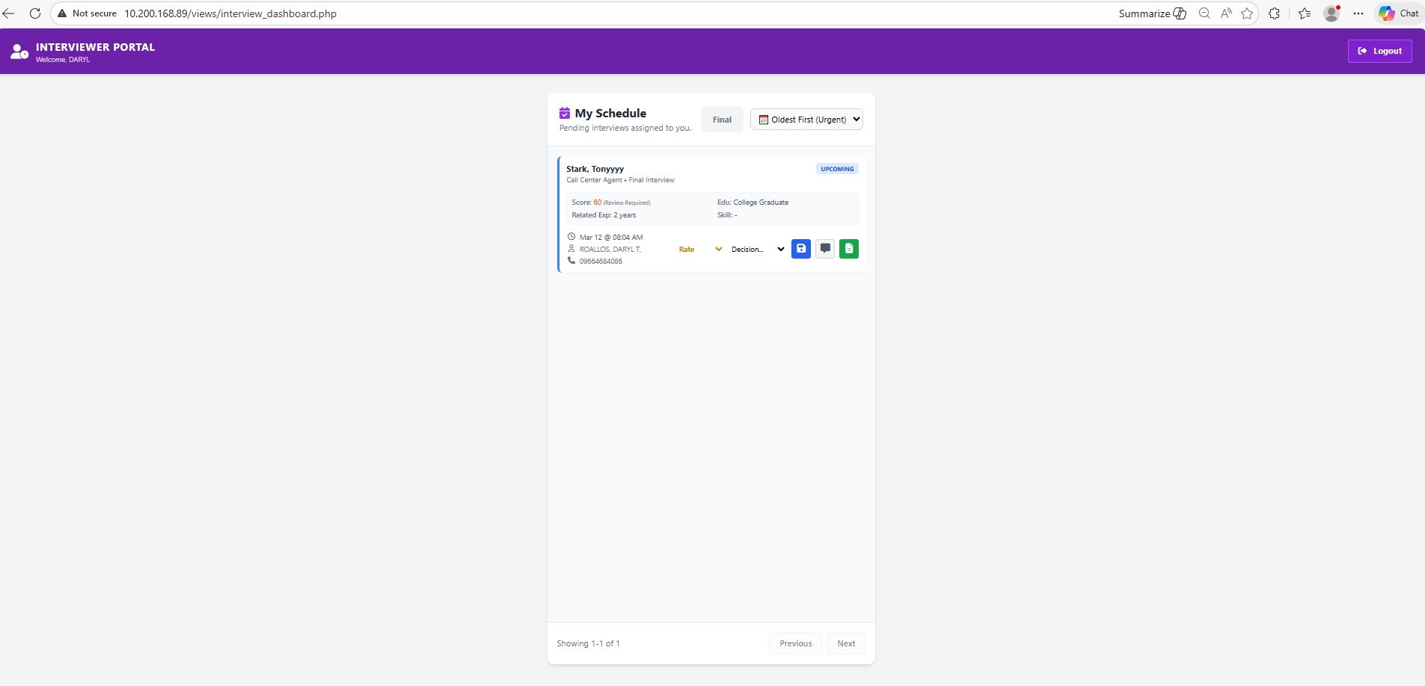
Figure 56: Microsoft Edge

Desktop View (Applicant Userform)
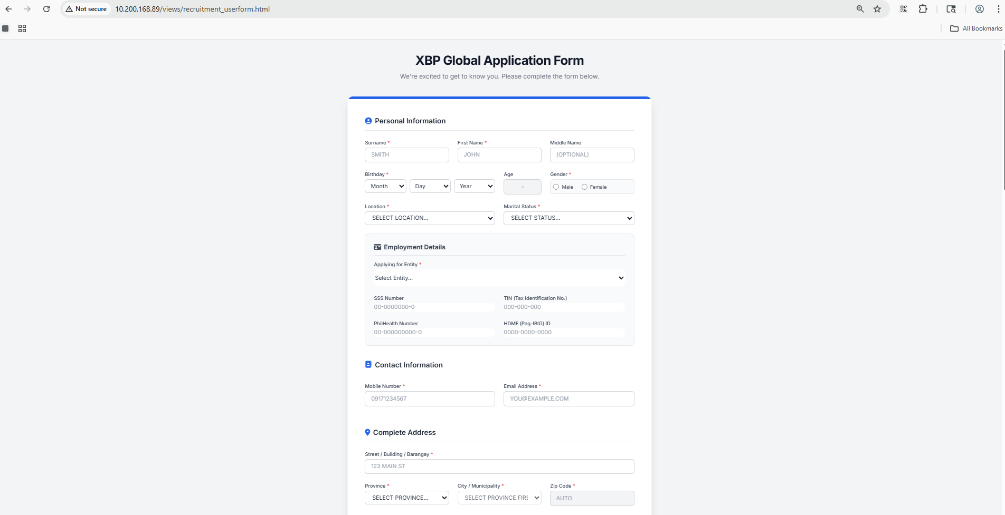
Figure 57: Google Chrome
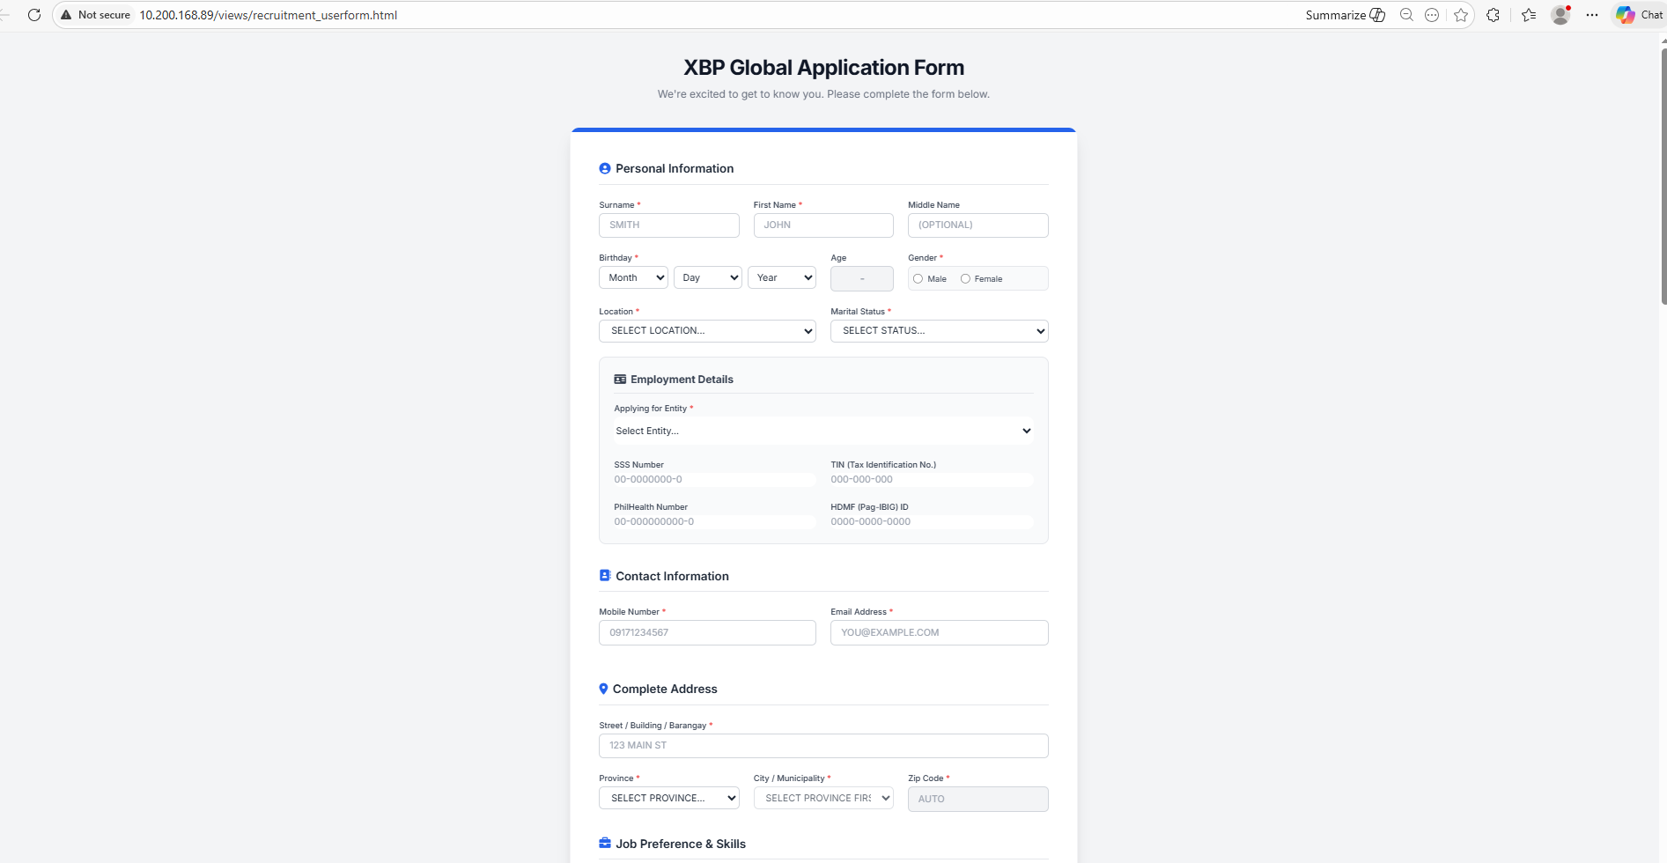
Figure 58: Microsoft Edge

Appendix C
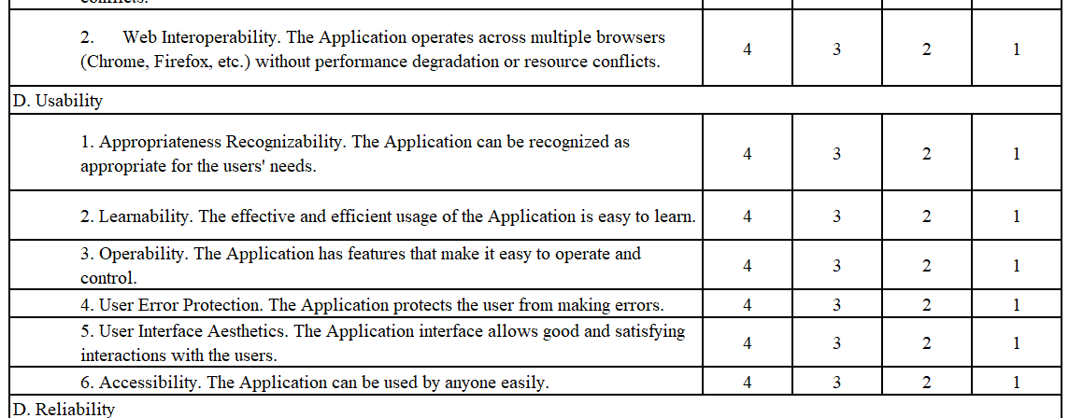
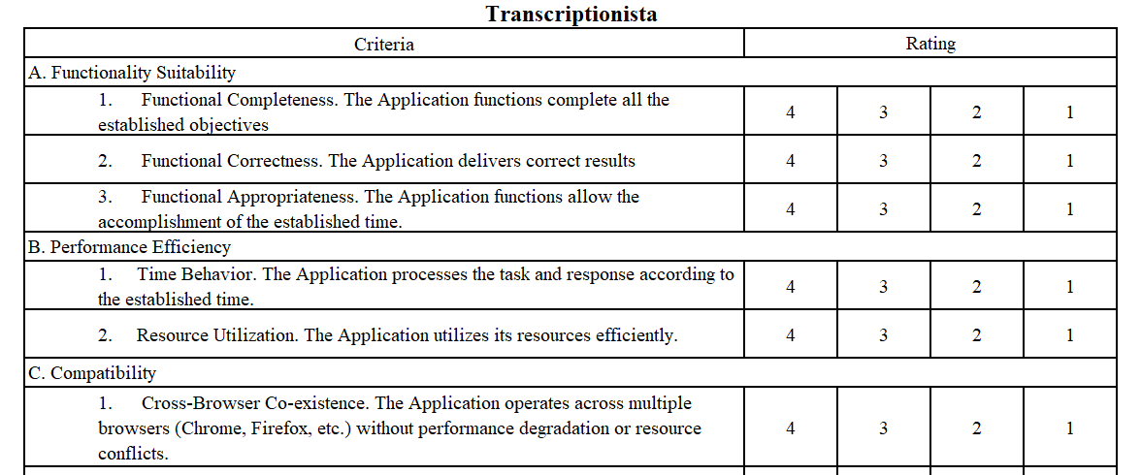
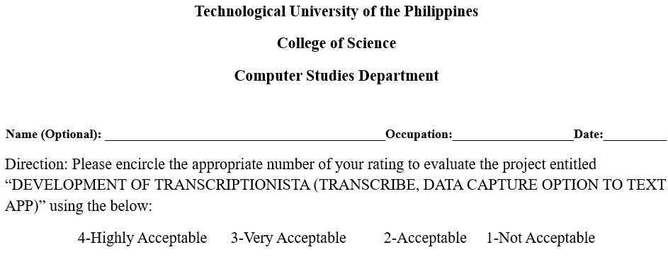
SAMPLE EVALUATION SHEET

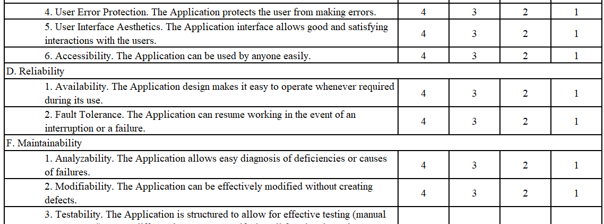
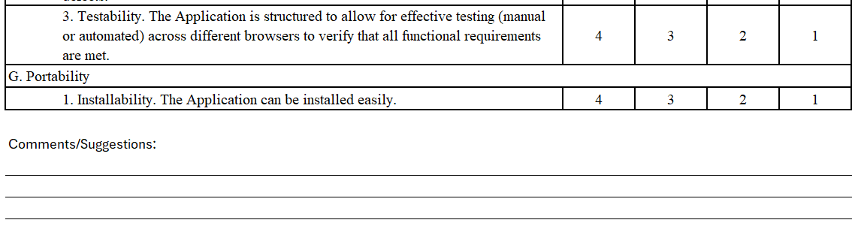

Appendix D
SURVEY QUESTIONNAIRE AND RESULTS SHEETS

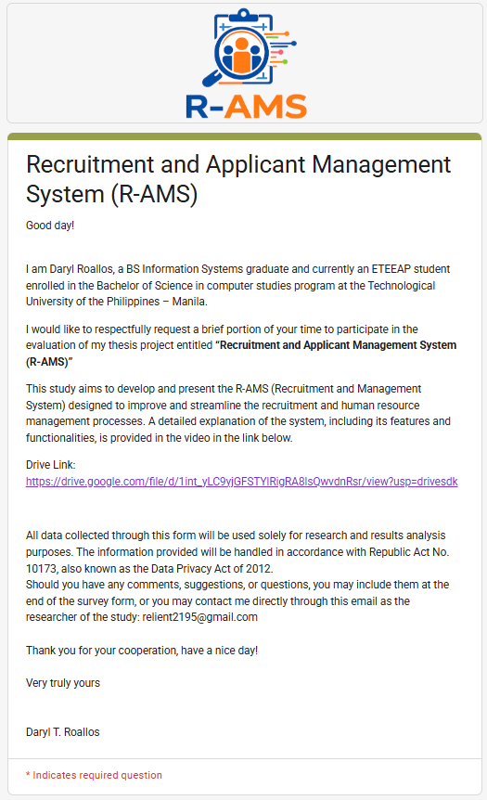

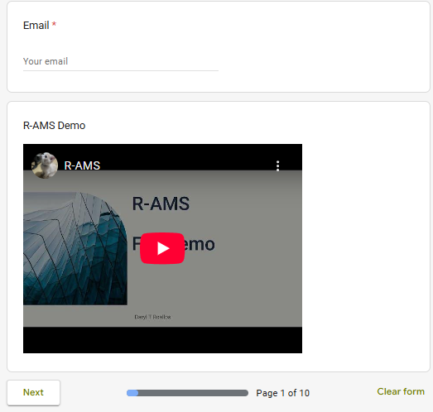

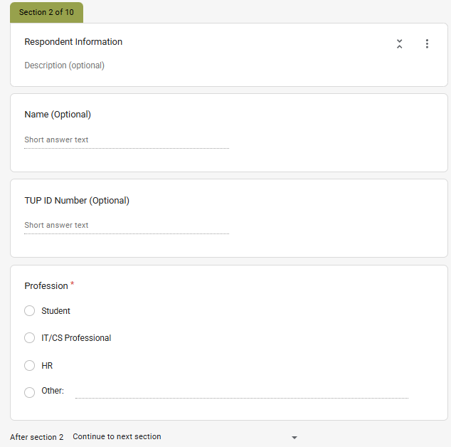

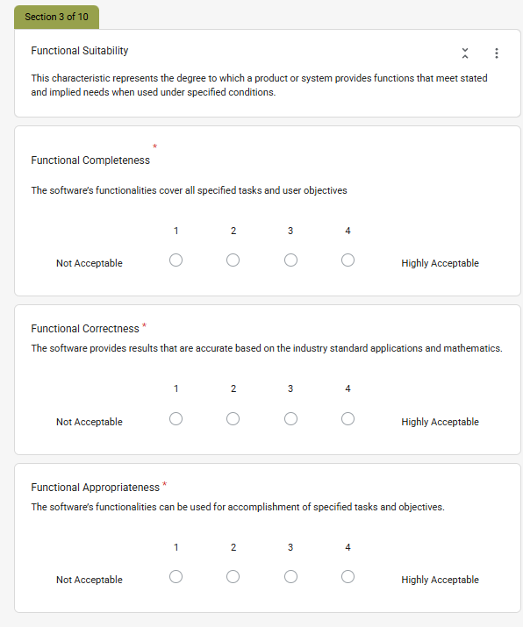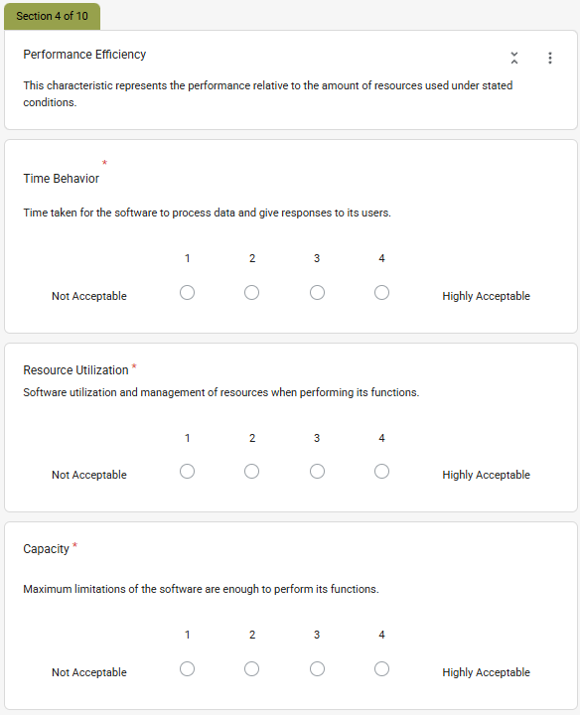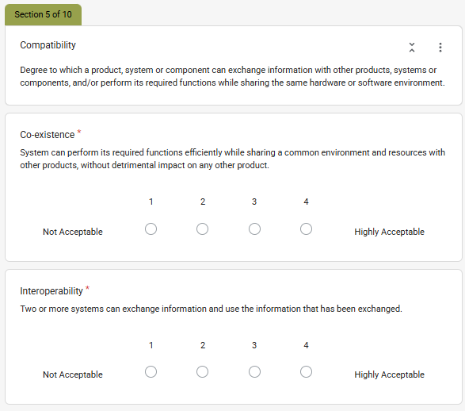
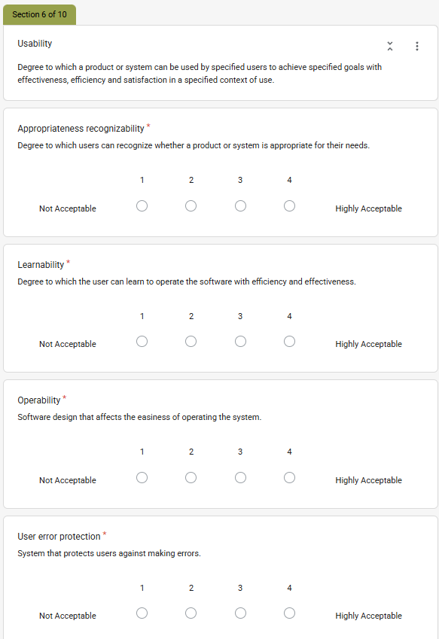

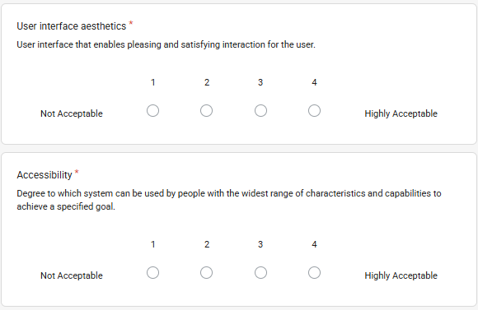

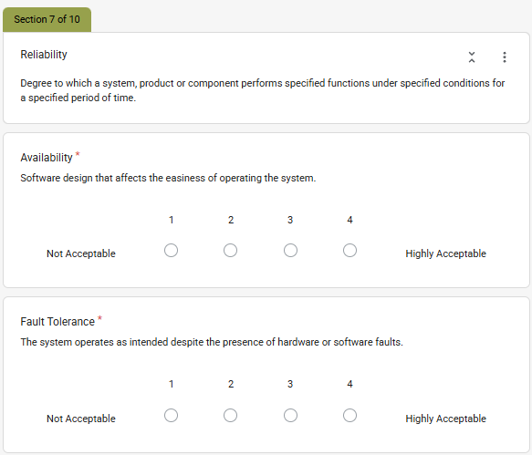
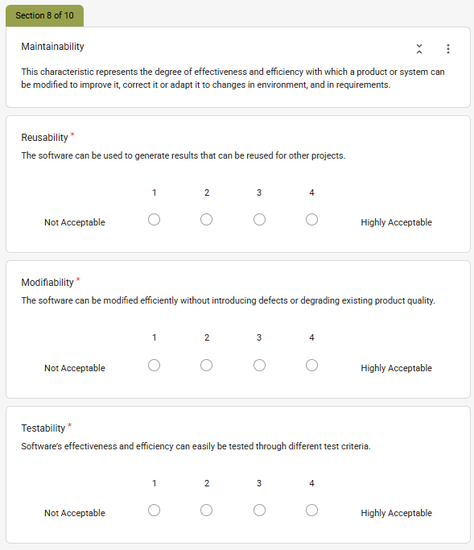

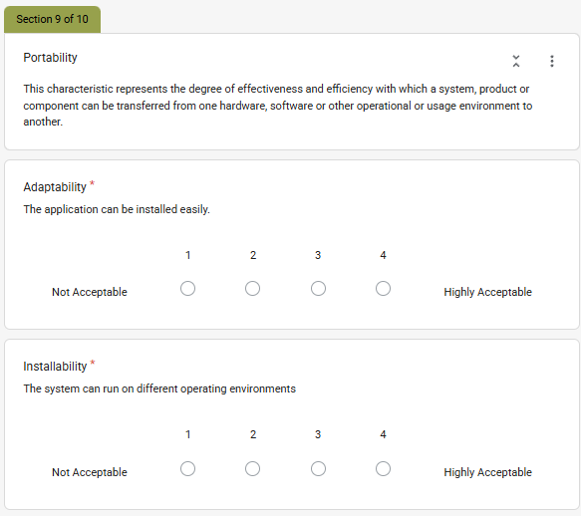

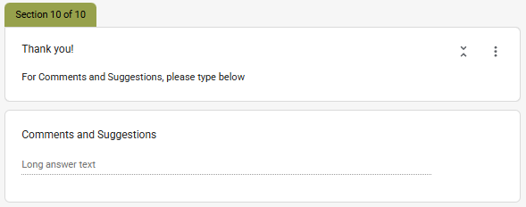

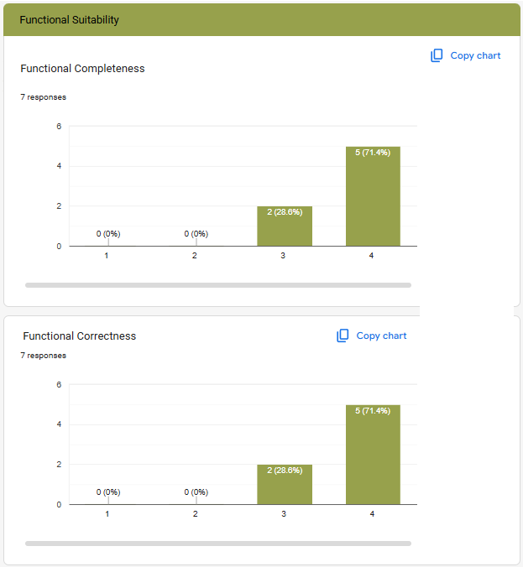

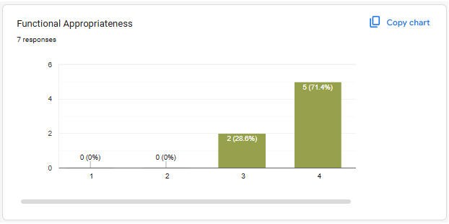
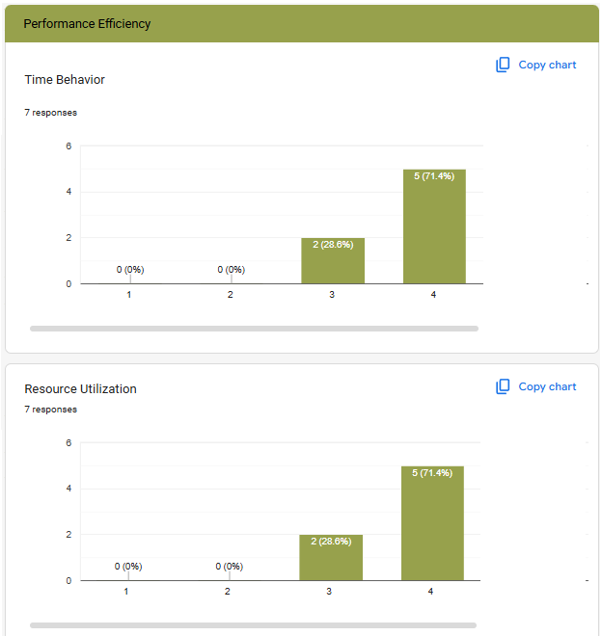

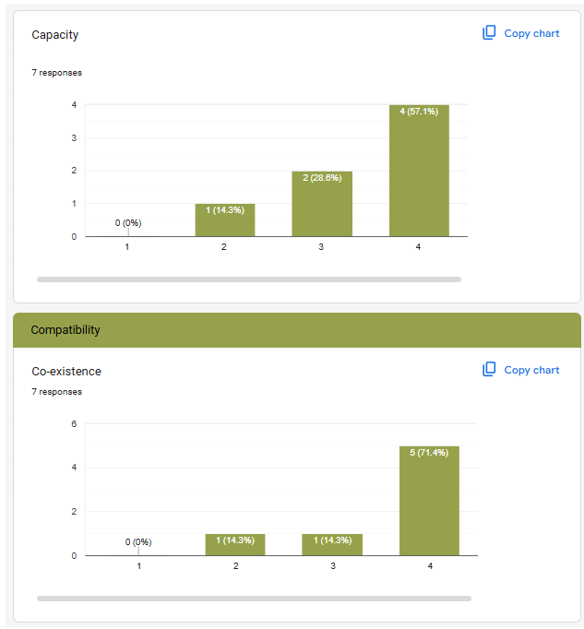
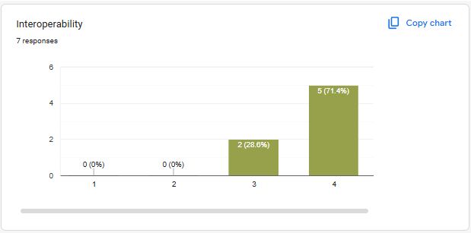

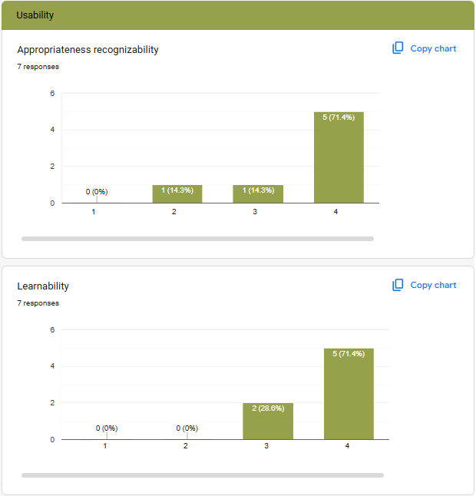

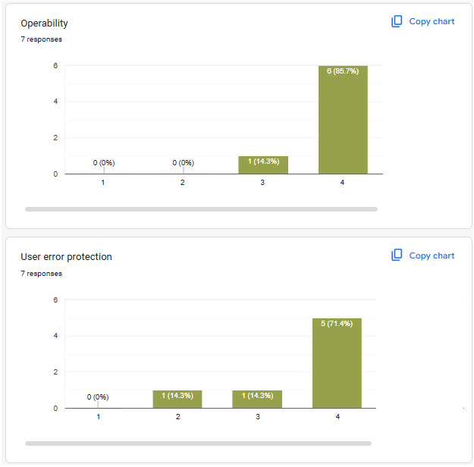

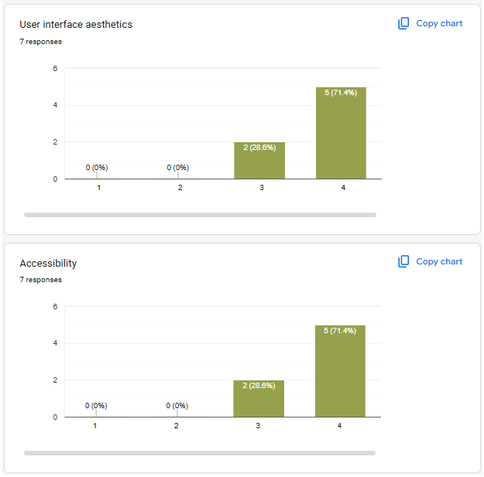

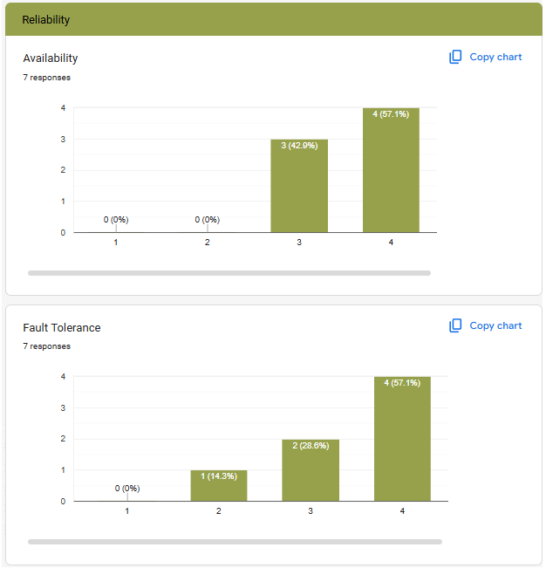

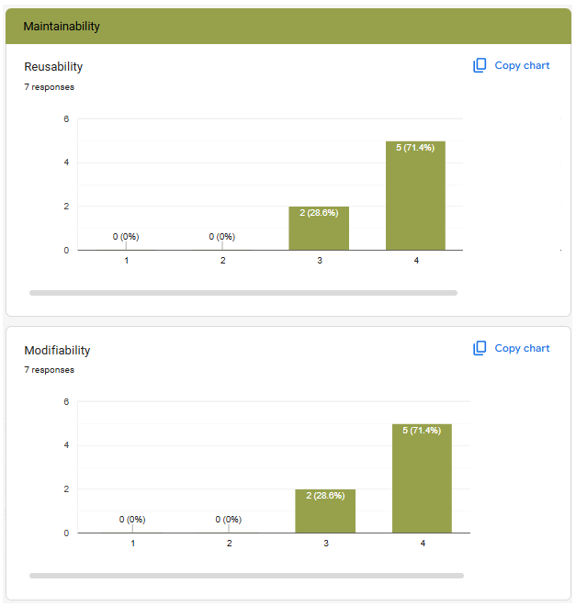

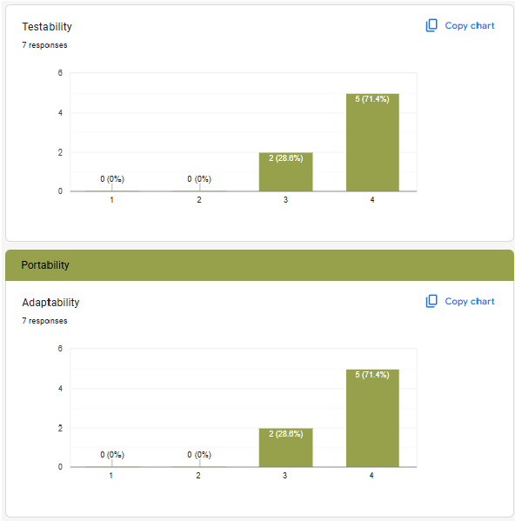

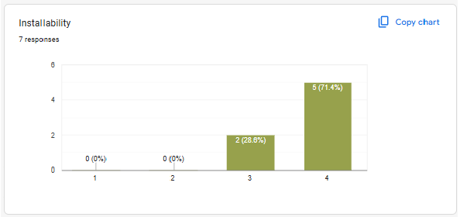

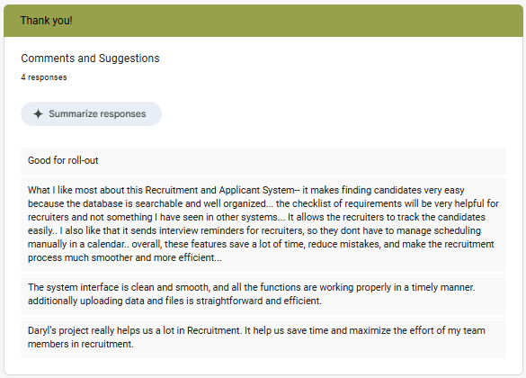

Appendix E
Thesis Grammarian Certificate

USER PROFILE

